A System Thinking and Modeling Process for inquiring Socioeconomic Problematic Situation in National Level

- Genesis: MIT
- Basic Concept: Behaviour based Structure; Mental model; Feedback Thinking; Endogenous Point of View; the field of simulation modeling;
- The SD Intervention Process: Different process
- The Stages of SD: 5 steps
- Genesis: Lancaster University
- Basic Concept: Problematical situation; Worldview; Purposeful action as a system;
- The SSM Intervention Process: four different kinds of activity.
- The Stages of SSM: 7 stages analysis process
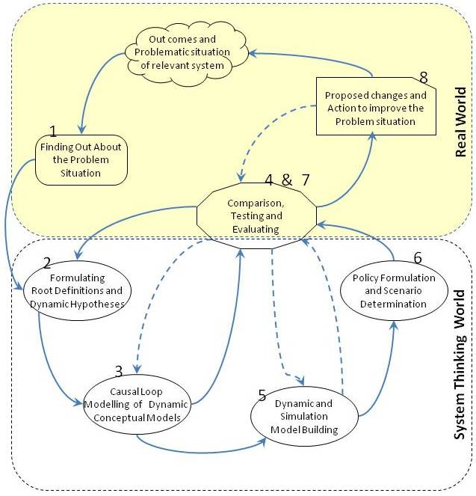
Soft Systems dynamics Methodology (SSDM)
Rodrı´guez-Ulloa (2000)

Holon Dynamic
Lane and Oliva (1998)
Combination or Synchronization
System Dynamics Methodology (SD)
Forrester (1960s) and others

Soft Systems Methodology (SSM)
Checkland (1970s)

Hard System Thinking Approaches
Oriented to goal seeking;
Positivistic Philosophy;
Functionalist Sociology;
Assumes the world contains systems that can be engineered;
Ontology-based;
Talks of "problems" and "solutions."
Soft System Thinking Approaches
Oriented to learning;
Phenomenological Philosophy;
Interpretive Sociology;
Assumes the world is problematic but can be explored using system models;
Epistemology-based;
Talks of "issues" and "accommodations
Summary of Theoretical Fuondations

System Thinking Paradigm
Summary of Proposed Modeling Process

 | phase | Activities
1 | Finding Out About Problem Situation | - Looking at the Unstructured Problem Situation  - Preliminary Information & Data Collection  - Boundary Selection  - Rich Picture Building  - Cultural Analyses | Real World
2 | Formulating Root Definitions and Dynamic Hypothesis | - Understanding Worldviews  - Describing the Purposeful Activity  - Expressing Dynamic Hypotheses | System Thinking World | Conceptual and Dynamic Modeling
3 | Causal Loop Modelling of Dynamic Conceptual Models | - Identifying the Key Activities and Variables  - Causal Loop Mapping
4 | Comparison,  Testing and  Evaluating | - Comparing and Testing the Models Structure and Behavior  - Analyzing Models Behavior to Identify Key Leverage Points | Both
5 | Dynamic and simulation Model building | - Identifying Stock and Flow Variables and Constricting Dynamic Diagram  - Constructing Computer Simulation Models  - Steady State and Parameter Sensitivity Test | System Thinking World | Scenario Planning With Simulator
6 | Policy Formulation and Scenario Determination | - Scenario Specification  - Determination and Simulating Scenarios
7 | Comparison,  Testing and  Evaluating | - Behavior Sensitivity Analysis  - Scenario Analysis | Both
8 | Proposed Changes and Action to Improve the Problem Situation | - Selection Systematically Desirable And Culturally Feasible Changes | Real World

