CHAPTER III

THEORETICAL FOUNDATIONS

3.1 INTRODUCTION
The modern world in the 21st century is involving in a wide variety of growing complex, dynamic problem situation. Situations characterized by rapid change, multiple interests, limited resources, and high complexity are good candidates for a "systems thinking approach"; Indeed, Systems thinking is a paradigm for viewing reality based on the primacy of the whole and relationships which can contribute a better understanding and solving dynamic problems. Manni and Cavana (2007) believe that we need system thinking for following reasons:
“Increasing complexity in the world and n personal lives; Growing interdependence of the world; Critical need for change in management and leadership theories and practice; Mutual interdependence of global and local thinking and action; Increasing recognition of a common heritage and destiny for mankind” (Manni & Cavana, 2007 p5).
The twentieth-century has witnessed the development of a systems paradigm and different spheres of systems knowledge. The systems approach is a different way of dealing with the planning and direction of action that emphasizes a process. It would influence the decision components, including premises, assumptions, cognitive style, and the method of inquiry. All share the concept of a multi-disciplinary approach to defining and solving complex, high-variety, dynamic, continuous, and interactive problems. Systems methodology or the systems approach refers to a set of conceptual and analytical methods used for systems thinking and modeling.
3.2 SYSTEM THINKING CONCEPT
The term “system” is a very broad concept that relates to various areas such as social systems, technological systems, and natural systems. In fact, the root of the word system is derived from the Greek synhistanai, ‘a complex whole put together’ (Skeat 1993, p468; Capra 1996, p27). However, as Checkland (1999) states, “…systems concepts are concerned with wholes and their hierarchical arrangement rather than with the whole” (p. 14). In the sense that the whole is more than the sum of its parts, this axiom is a basic philosophical assumption of systems theory (Capra 1996; Gibson, Ostrom et al. 2000). Therefore, the core system concept is that an adaptive whole (system) can survive throughout time by adapting to the changing surrounding environment (Checkland & Poulter, 2006). In this respect, it implies interaction and interdependence (Forrester, 1961). As Chakland (1991) argued survival of a system through time needs communication processes, control processes, a layered structure and emergent properties of the system as a whole.
Having said that, the process of understanding how things interact with each other within a whole is the key concept of Systems thinking. Therefore, system thinking is a scientific filed of knowledge for understanding change and complexity through the study of dynamic cause and effect over time (Manni & Cavana, 2007). Checkland (1991) believe that this scientific filed has arisen in part in response to three problems in science: “complexity in general, the extension of science to cover social phenomena, and the application of science in real world situations” (p74). In this respect, Manni and Cavana (2007) defined three distinct dimensions for this scientific filed:
“Paradigm” as it is the way of thinking about the world and relationships; “Language” as it provides a tool for understanding complexity and dynamic cause and effect; “Methodology” as it incorporates a set of modeling and learning technologies.
3.2.1 Two Main Different Paradigm in System Thinking Approaches
When we look at all the different fields of the system approach a similar picture has emerged. However, there has been considerable debate within the systems field about the merits of one approach over another. More specifically, there has been a divide between the so-called ‘hard’ and ‘soft’ approaches (Rees, 2000). Although, there are basic differences in the two (hard vs. soft) approaches, both Soft and hard systems methods are used to solve real-world problems (Ekasingh & Letcher, 2008).
Often, there is confusion on the value or importance and concept of hard and soft system in system thinking. Barry and Fourie (2002) state that hard systems apply to structured problems while soft systems apply to unstructured problems. In another attempt, Rose and Haynes (2001) classifies hard systems are those that are designed physical systems, and soft systems as those involving social, cultural and organizational considerations. However, Checkland (2000) provides interesting perspective of hard and soft systems in figure 4.1. The figure generally supports the distinction between the two on the basis of their most-suited problem contexts:
- Hard system is based on the assumption that the world is a collection of interacting systems, and we can engineer the one which do not work very well in order to work better.
- Soft system is based on the assumptions that the world is taken to be very complex, problematical, and mysterious. However, by the process of inquiry into it, it can be organized exploration as a learning system.
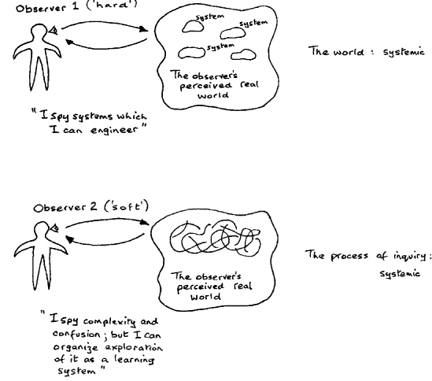

Figure 3.1: The hard and soft system perspective (Source: Checkland, 2000 )
In the first perspective, the world is considered to be systemic and is studied systematically that reflects the notion of hard systems thinking paradigm; while in the second perspective, the world is problematic, that is, it admits to many different interpretations and we study it systemically that reflects the notion of soft systems thinking paradigm.
3.2.2 Hard versus Soft System Thinking Approaches
Hard systems thinking approaches are best applied to well-defined, goal-oriented, quantifiable, and real world problems (Midgley, 1996). It can be characterized as having an objective or end to be achieved, and a system can be engineered to achieve the stated objective, the problem is structured so there is a gap in between the desired future state and the present state; how to make the gap disappear is the problem. These approaches often involve the use of quantitative approaches in the form of spreadsheets, computer simulations, statistical analysis, or potentially large mathematical models and optimization techniques. They have been successful to deal with highly complex physical systemic relationships or in problem situations that may have considerable technical complexity, but in general can only cope with low human complexity and low to medium divergence of interests (i.e. multiple objectives, in contrast to values).
Among the popular hard system thinking approaches which used for solving social, environmental and economic problems Examples would include: systems engineering; system dynamics (SD) (1956); Viable Systems Model (1959); and other approaches that are at the system analysis and old style operations research.
In contest, soft systems thinking approaches are best applied to ill-defined, fuzzy problem spaces, usually made this way because of the unpredictability of people, uncertainty, and other cultural considerations (Midgley, 1996). soft systems approaches address problem situations which are messy, ill-structured, and ill-defined in terms of their human components and relationships, not independent of the people involved, in other words, it deal with problems that cannot simply be defined and useful for engaging human beings and existence point of views in the real world. This approach focuses on a better understanding of complex systems by an iterative learning process (Wit, 2011). Examples would include soft systems methodology (SSM) and soft operations research. They are characterized by structuring the problem situation, rather than by problem solving. As matter of fact, Checkland’s soft systems methodology (SSM) are firmly based on systems thinking and systems concepts.
For more shed light, the characteristics of hard and soft systems thinking approaches are summarized in Table 3.1. The table generally supports the distinction between the two on the basis of their most-suited problem contexts.
Table 3.1 Hard versus Soft systems thinking
 | Hard system thinking Approaches | Soft system thinking Approaches
Purpose of the study:
 | - Oriented to goal seeking.  - taken as a given at the start | - Oriented to learning.  - remains at the start problematical
Methodology nature:
 | - Positivistic Philosophy.  - functionalist Sociology | - Phenomenological Philosophy.  - interpretive Sociology
System perspective:
 | -Assumes the world contains systems that can be engineered.  -Systemicity (the complex, dynamic behavior) lies in the world | -Assumes the world is problematic but can be explored using system models.  - Systemicity lies in the process of inquiry into the world
Modelling:
 | -Assumes system models are models of the world (ontology-based).  - Shared representation of the real world  - Purpose of modelling: understanding or changing the world, linked to the purpose | -Assumes system models are intellectual constructs (epistemology-based).  - Representation of concepts relevant to the real world.  Purpose of modelling: a means to support learning
Problem definition:
 | -Talks of "problems" and "solutions."  -Clear and single dimensional (single objective) | - Talks of "issues" and "accommodations."  -Ambiguous and multidimensional (multiple objectives)
Advantages:
 | -Allows the use of powerful techniques. | -Available to both problem owners and professional practitioners. Keeps in touch with the human content of problem situations.
Disadvantages:
 | -May need professional practitioners.  -May lose touch with aspects beyond the logic of the problem situation. | -Does not produce final answers.  -Accepts that inquiry is never-ending.
Adapted from Pidd (2004, p10), Checkland and Holwell (2004 p54), Checkland (1985, p765),
3.2.3 System Dynamics: Hard or Soft Approach
The original System dynamics concept in the sixties was very focused on mathematical modeling and the replication of real world behavior using clear positivist/objective approaches. It, therefore, have tended to be used in conjunction with essentially hard systems methodologies ( Jackson, 1991, keys, 1988, Dash, 1994). Similarly, it has been assumed that system dynamics approach must be a type of hard system modeling due to involving equation and simulation modeling (Morecroft, 2007). Therefore, some authors included system dynamics between functionalistic, deterministic, and hard managerial disciplines (Forrester, 1991). However, this methodology yields hard models from a soft and interpretive model building process (Lane, 2000).
Forrester (1992) reported that in recent years the system dynamics concept has changed because of its inclusion in a number of more general system thinking concepts and systems methods. These attempts moved system dynamics from the hard concept to a much softer paradigm. As Senge (1990) in the book -The Fifth Discipline -dealer system dynamics has many connections to various schools of thought. He is one of the system dynamics practitioner that developed bridges between two strands of Systems theory: System dynamics and System thinking. Lane (2000) extensively argued that from the perspective of social theory and system science, system dynamics is not a hard or deterministic approach. He believes that what was happening to system dynamics can be seen as an intellectual evolutionary journey that has started from its initial conception by Forrester (1961) in the 1960s.
Today Premises of system dynamics has left functionalistic beginnings, and has been moving toward phenomenology and approaches close to interpretative and learning paradigms. (Forrester, 2007). So modellers in system dynamics do not spy system. Rather they spy dynamics in the real world, in other word, they seeks to discover enduring feedback structure as hidden characteristic of real world and organize modelling as learning process. “This is hard system modelling dressed in soft clothing” (Morecroft, 2007 p152).

3.3 SOFT SYSTEMS METHODOLOGY (SSM)

3.3.1 Genesis of SSM
Soft systems methodology (SSM) originated from the understanding that hard Systems Thinking approaches were inadequate for enquiring into large, complex and human activity systems, the “systems where human beings are undertaking activities that achieve some purpose” (Patching, 1990). SSM has been developed during the 70s in the systems department at Lancaster University by Peter Checkland and his colleague. After World War II, when systems engineering was applied from military engineering to civilian enterprises, it is founded that some of the situations are quite different from operational research. Professor Peter Checkland and Other members of the systems department, Dr Brian Wilson, Professor Gwilym Jenkins and Dr David Rippin, founded that it is difficult to use the objective language in human affair systems because there are no such common goals existing in the social world. Checkland had noticed that "hard" systems processes, which moved from defining objectives and measures to evaluating alternatives and making choices, were not effective when the problems could not be stated clearly. Based on different worldviews (Weltanschauung), different cultural backgrounds and different interests, participants involved into the problem situations have their own ambiguous or unambiguous aims for these situations and always contradict each other.
The methodology has developed mainly as a result of consultancy work and through action research, through a long series of industrial projects (Mingers 2000a). As more experience was gained dealing with different sorts of problem situations, the learning was analyzed and incorporated into the methodology. As a result of this challenges it is known as a problem solving methodology for ill-defined problem situations in human activity systems.
The development of SSM has been well documented in three books (Checkland 1981; Checkland and Scholes 1990; Checkland and Holwell 1998) , Systems Thinking, Systems Practice, is the primary reference on this model and the second of which (SSM in Action) is wholly concerned with applications of SSM. Checkland’s “short, definitive account” was published in 2006 (Checkland and Poulter 2006).

3.3.2 Basic Concept and Theoretical Assumptions of SSM
The literature by Checkland and his collogues about SSM say a lot about the ontological, epistemological, and methodological foundations. From the main literature review, the main sources that mentioned in pervious section, it can be seen that the ontological status of SSM as lying in an interpretative or socially constructed view of reality, its epistemology as the exploitation of systems constructs to structure learning, and its reasoning strategy as that of model building and testing. The investigative force of the methodology derives not from an ontological view of a systemic world, but the epistemological power of a set of systems concepts, which may structure thinking about the world. Therefore, in trying to understand SSM it’s important to have the knowledge about its basic concept and theoretical assumption as follows:
Problematical situation
We all live in the midst of a complex interacting flux of changing events and ideas which unrolls through time. We call it ‘everyday life’, both personal and professional. Within that flux we frequently see situations which cause us to think: ‘Something needs to be done about this, it needs to be improved.’ Think of these as problematical situations, avoiding the word ‘problem’ since this implies ‘solution’, which eliminates the problem for ever. Real life is more complex than that! (chakland, 2006). One example is a government trying to define a legislation to increase the feeling of security on the street for its citizens in a time of terrorist threats without diminishing civil liberties.
Having said that, there are no optimal solutions in SSM. Chackland emphasizes that SSM does not seek solutions which solve real-world problems. Those ideas are a mirage when faced with real-life complexity, with its multiple perceptions and agendas. Instead, SSM focuses on the process of engaging with that complexity (Chakland, 2006). Therefore, SSM is not concerned with the objective study and optimal solution of problems; instead, it is intended as a methodology to explore, question and learn-about ill-structured problem situations or ‘messes’ (Ackoff, 1974). As Platt and Warwick (1995) confirmed SSM does not aim to solve the problems in one fell swoop but to make incremental improvements.
Worldview (Weftanschauung)
When we interact upon real world situations, we make judgments upon what happens. This could be “good/bad”, “acceptable/unacceptable”, “permanent/transient”. To make these judgments we have different criteria which we match the situation against to make a judgment. These criteria can be very different from person to person, what some people call a ‘freedom fighter’ might be considered a ‘terrorist’ by others. These criteria and the results they produce builds up to a personal worldview over time. These worldviews can also change over time. (Checkland, & Poulter, 2006). Checkland uses the term Worldview (Weftanschauung) to capture the interpretive stance, or perspective; that individuals adopt in order to define and interpret a problem (Lean & Oliva, 1997).
None of the other systems approaches pay attention to the existence of conflicting worldviews, something which characterizes all social interactions. In SSM the (social) world is taken to be very complex, problematical, mysterious, characterized by clashes of worldview. Then reality, under this perspective cannot, in itself, be assumed to have systemic properties. Hence, SSM as a methodology lends itself, particularly well for dealing with situations where there exist many different perspectives, values and beliefs around what aspects of the situation are most important and how to address them. Soft systems methodology can be a way of eliciting information about attitudes and values that are crucial to the simulation of human dimensions within a quantitative model (Ekasingh, & Letcher, 2008).
Purposeful action as a system:
All problematical situations, as well as containing different worldviews, have a second important characteristic. They always contain people who are trying to act purposefully, with intention, not simply acting by instinct or randomly thrashing about (chakland 2006). To clear the concept of purposefulness Checkland and Scholes (1990) argued: ‘‘one of the most obvious characteristics of human beings is their readiness to attribute meaning to what they observe and experience’’ and that ‘‘... they can then decide to do some things and not do others. They can take purposeful action in response to their experience of the world. By purposeful action we mean deliberate, decided, willed action, whether by an individual or by a group’’ (p 1–2).
Having said that, Checland as the founder of SSM believes that the relevance of system thinking to SSM emerged when it was realized that every single real-world problematical situation, has the purposeful action characteristic in common. In the sense that, all situations contain people trying to act purposefully not simply acting by instinct or splashing about at random. Hence, this is the key finding that makes it meaningful to treat the purposeful action as a system, or as Checkland puts it: “A logically linked set of activities constitute a whole – its emergent properties being its purposefulness."
Most importantly, however, the purposeful activity models can never be descriptions of something in the real world. Each of them expresses one way of looking at and thinking about the real situation, and there will be multiple possibilities. This means that models of purposeful activity, in the form of systems models built to express holonic ideal types of organized human behavior under a particular worldview, can be used as devices to explore the qualities and characteristics of any problematical human situation. Consequently, several models are used to explore the problem situation under different perspectives. Checkland, (1988) proposes the word ‘holon’ to distinguish the systemic construct from the real world entities commonly labeled as systems. In other words, a holon is a particular type of model, one which organizes thinking using systemic ideas. As he has stressed, in order to incorporate the concept of worldview into the approach being developed, it was necessary to abandon the idea that the world is a set of systems. Accordingly, SSM views models as a means of thinking about reality rather than models of reality (Bennetts, Wood-Harper & Mills, (2000). Therefore, systems do not exist in reality, but are conceptual constructs that aid in understanding reality (Checkland 1999). Then, helps to structure thinking about situations in the real world (Rose and Haynes 2001).
Methodology with a flexible Process
Every situation involving humans is unique and change over time, that is, if two situations are very similar nothing ever happens twice, not in exactly the same way. If they were, the optimal way would probably be to hand over the situation to a computer to calculate the optimal solution. To meet these types of situations it is needed to use a methodology rather than a method. Moreover, It is obvious from the argument so far that any methodology able to deal with the changing complexity of real life will have to be a flexible process. What defines a methodology is that it is a set of principles that can be adapted to be used in a way that suits the nature of the current situations in the best way (chackland 2006).
In conclusion, SSM is a methodology with a flexible process to deal with any complex real world situations. It provides a set of principles which can be both adopted and adapted for use in any real situation in which people are intent on taking action to improve it. SSM is thus not only a methodology for a specially set up study or project; it is, more generally, a way of managing any real-world purposeful activity in an ongoing sense.

3.3.3 The SSM Intervention Process
The SSM process takes the form of a cycle. SSM is thus not only a methodology for a specially set-up study or project; it is, more generally, a way of managing any real-world purposeful activity in an ongoing sense.
The SSM cycle is shown in Figure 3.2, which eventually emerged as its classic representation. It contains four different kinds of activity:

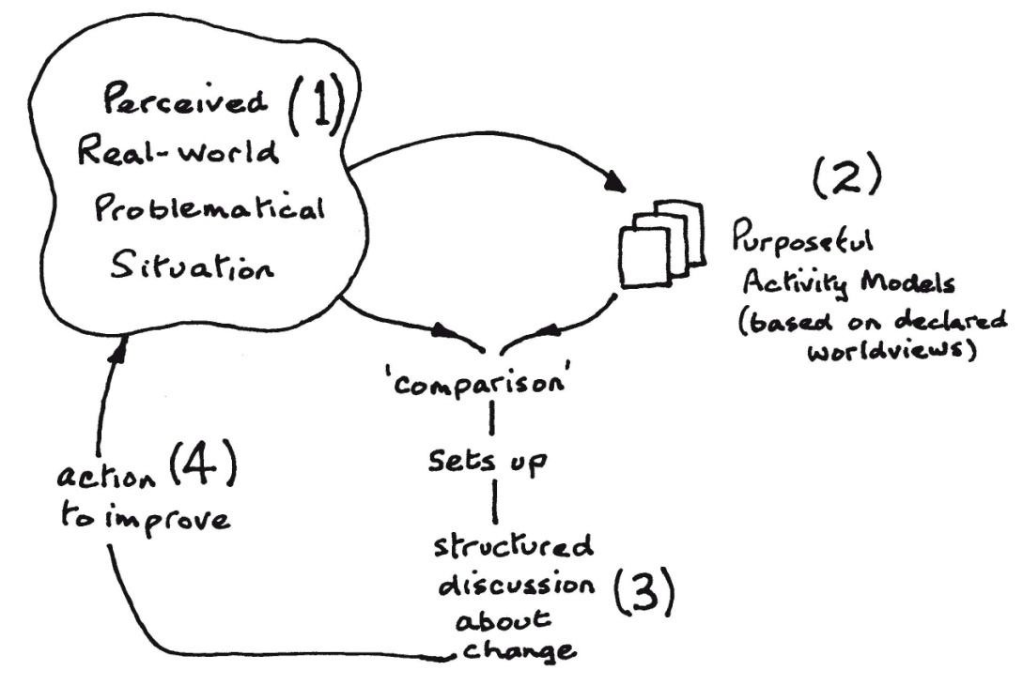
Figure 3.2 SSM intervention process. Source: Chekland and Poulter (2010)
Finding out about the initial situation which is seen as problematical
Then SSM deals with fuzzy problem situations where objectives are unclear, and where there may be several different perceptions of the problem (Rosenhead, 1989). It partly aims to structure previously unstructured situations, where no particular problem has been identified, rather than to solve well-structured problems. The purpose of this phase is to form the richest possible picture of the problem situation to enable a wide selection of viewpoints to explore it (Checkland, 1981). Entering a real situation in order first to understand it calls for a particular frame of mind in the user of SSM. Since the complexity of human situations is always one of the multiple interacting relationships, a picture is a good way to show relationships. In the language of SSM, it is known as making Rich Pictures. Along with the initial finding out about the logic of the problem situation, a second line of inquiry is initiated to explore its cultural dimension (Checkland, 1988). This is carried out by three kinds of inquiry, known as the intervention itself, a social analysis (What kind of ‘culture’ is this?) and a political analysis (What is the disposition of power here?). These analyses are meant to be a continuous reflection and documentation process during the whole duration of the intervention.
Making some purposeful activity models judged to be relevant to the situation
Given the assumption that it is difficult to capture the full richness and diversity of social reality, SSM opts to build a variety of models, each representing a particular pure worldview over the problem situation. This kind of model is used because every human situation reveals people trying to act purposefully. A worldview is considered relevant if it “is likely to lead to illumination of the problem and hence to their solution or alleviation” (Checkland, 1981, p. 167). Since each model is built according to a declared single worldview such models could never be definitive descriptions of the real world. Each model is one way of looking at complex reality. It is worth noting that a model does not have to be a statement of something desirable to be relevant, i.e., insight can be gained by building models with worldviews that are not espoused by any of the agents in the problem situation. In this step of SSM need a statement describing the activity system to be modeled. Such descriptions are known in SSM as Root Definitions, the metaphor ‘root’ conveying that this is only one, core way of describing the system. In conclusion, the modeling process yields a systemic, logically derived, ‘ideal type’ of the assumptions stated by a particular worldview.
Using the models to question the real situation
Structure to the discussion is provided by using the models as a source of questions to ask about the situation. Therefore, this phase of SSM has usually been referred to as a comparison between situation and models which might be helpful in deepening our understanding of the situation and beginning to learn our way to taking ‘action to improve’. From this comparison, two outcomes are possible. Either more potentially relevant systems to be modelled are detected - in which case the modelling and comparison phases are iterated, or, alternatively, a number of changes to the problem situation are identified. Such changes are ones which the systems thinking reflected in the models recommends as being desirable, so they are said to be ‘systemically desirable’. This list of identified changes is further tested to ensure that the unique culture of the problem situation will be able to accept them. If so, the changes are said to be ‘culturally feasible’.
In brief, the expected output of this phase is, therefore, a set of insights and changes that emerge from the comparison of these ideal types with the real world problem situation and are acceptable to the agents involved in it.
Define/take the action to improve the situation
At the same time, the models create a structured debate about possible change what is required in this debate are accommodations, not consensus, between different outlooks and people which enable change. Finding an accommodation is usually a necessary condition for moving to decide what we will now do in the situation (Chekland and Poulter, 2007). Ultimately, SSM Acting to improve a real-world situation, in order to cope with the complexity of human affairs, entails finding, in the course of the discussion/ debate, accommodations among different worldviews.
Since the learning cycle is, in principle, never-ending it is an arbitrary distinction as to whether the end of a study is taken to be defining the action or actually carrying it out. Some studies will be ended after defining the action, some after implementing it (Chekland and Poulter, 2010). It is never-ending since taking action to improve the situation will change its characteristics. It becomes a new (less problematical) situation, and the process could begin again. Therefore, SSM inevitably causes a learning circle which itself is an organized learning system.

3.3.4 The Stages of SSM
The reasoning strategy of SSM centers around modelling that contains Unstructured modelling (rich pictures) which serves to abstract features of the problem domain is followed by formal textual modelling (root definitions) and activity modeling (conceptual models). Models are used as devices for reassessing and improving the problem solvers’ interpretations of the problem. The main feature of SSM is a 7 stage analysis process, which also provides stages of seeking, assessing, comparing, specifying and deciding (learning and planning) is illustrated in Figure 3.3. Unlike other system analysis methods, which guide the user through a structured process from problem definition to solution implementation, SSM is a set of guidelines that help the analysts in performing the analysis, while allowing a considerable scope of personal interpretation.
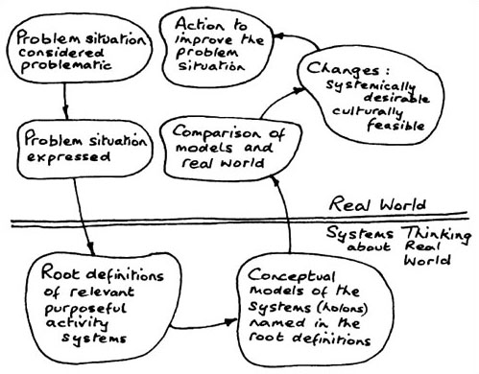
Figure 3.3 The main feature of SSM is a 7 stage analysis process
The stages are:
Problem Situation Considered Problematic
In the first stage, the analyst is learning and understanding the problem situation. The reason for the initiation of the analysis is usually a general feeling of uneasiness from the person/body who asked for the analysis (the problem owner). The term problem situation is used to describe the specific problem and its environment, as the analyst should approach the investigation with an “open mind” and should not limit himself to a limited context. In this stage, the analyst reads background material, performs interviews and other activities that are needed in the learning process.
Problem Situation Expressed
The second stage is to express the problem situation. The output of this stage is the rich picture. A rich picture is a schematic tool that helps the analyst in describing the problem situation. They are also a communication tool which the problem owner and other stakeholders when discussing the problem situation can use. The discussion aim is to ensure that the analyst understand the problem.
Root Definition of Relevant Purposeful Activity System
In stages 3, the analyst detracts himself from the system and analyses it. The first output is the creation of root definitions. Root definitions describe what the system is and what it aims to achieve - as each stakeholder sees it. By subscribing the root definition, the different views about the problem and the expected solution are expressed clearly.
Conceptual Models of the Systems (Holons) Named in the Root Definitions
The root definitions form the base for the conceptual models - a model that describes how the activity that the root definition describes can be achieved practically - input, output, transformation (the processes that transform input to output), control element and relations between these elements.
Comparison of the Models and Real World
In stage 5, the conceptual model is compared with the rich picture and discussed with the problem owner. Again, the problem owner should participate and approve the conceptual models that the analyst created.
Changes: Systematically Desirable and Culturally Feasible
In stage 6, the analyst and the problem owner deliberate and discuss what changes are feasible and practical. Some changes might be impractical due to political, structural, financial, ethical or other reasons.
Action to Improve the Problem Situation
After clearing out the necessary (and feasible) changes, these changes can be implemented and added to the system. It works with the idea of finding an accommodation among a group of people, with different worldviews, with a common concern.
It is important to pay attention that, first, during the SSM cycle it is possible to repeat and reiterate stages as necessary. If, for example, several changes are rendered impractical, the analyst can go back and search the rich picture for different solutions, and repeat stages 3-5. Second, there is a line separating the “real world” from the “systems world”. The “real world” is the world where the problem is occurring and the human activity takes place. The “systems world” is the analyses' context in which the information from the real world is scrutinized and dissected in the problem solving process. Finally, it is worth to say that the common theme SSM cycle is before attempting to change something, one should understand comprehensively what it is that makes the area of interest ‘tick’. The (feasible and desirable) actions can then be aligned more accurately against the problem space and its areas of change vulnerability.

3.4 SYSTEMS DYNAMICS (SD) METHODOLOGY

3.4.1 Genesis of System Dynamics
It was originally created in 1957 by Jay W. Forrester of the Massachusetts Institute of Technology as a method for building computer simulation models of problematic behavior within corporations (Radzicki, 2011) to help in the managerial decision-making process, and later to the physical and biological sciences such as ecology (Forrester, 1971). He sketched the worldview of what would be known as “system dynamics” with a strong criticism of economic models in a “note” to the Faculty Research Seminar, the first ever MIT “D-memo”. After delineating these points, Forrester then proceeded in the same note to highlight techniques that were largely underused at that time: servomechanisms, differential equations, and what he called “the art of simulation” ( see Olaya 2009 and Forrester, 2003).
A subsequent advance came in 1958 with an article entitled “Industrial Dynamics (OLAYA 2009). It has long since justified the change of title from Industrial Dynamics (1958) to System Dynamics (1970 onwards) (Dangerfield 2009). Since his first presentation almost more than a half century, System dynamics has been applied to a variety of pursuits, ranging from problems arising in complex social, managerial, economic, or ecological systems. System dynamics can be applied to any dynamic system, with any time and spatial scale (sterman 2000).
Now SD has a strong literature base. The development of SD has been well documented in many books. Although, detailed explanation of this field in Industrial Dynamics (Forrester, 1961) is still a significant statement of philosophy and methodology, Richardson and Pugh (1981), Roberts et al. (1983), Coyle (1996), Ford (1999), Sterman (2000), Warren (2002), Maani and Cavana (2007), Morecroft (2007), Qudrat-Ullah et al. (2008) and others are books that describe and developed system dynamic methodology. All these books provide tools, techniques and modeling examples suitable for the novice as well as for experienced System Dynamics modelers. Also available in: ‘Complex Systems in Finance & Econometrics’, (Robert A. Meyers 2010) and the Encyclopedia of Complexity and Systems Science (Robert A. Meyers 2009) including the system dynamics topics. Moreover, the System Dynamics Society is an international, nonprofit organization devoted to encouraging the development and use of system dynamics and systems thinking around the world. The International System Dynamics Society maintains a comprehensive bibliography of over 8,000 scholarly books and articles documenting a wide variety of applications of System Dynamics modeling to applied problems in all sectors (Andersen, Rich, MacDonald, 2009).

3.4.2 Basic Concept and Assumptions of System Dynamics
Meadows (1989) provides a statement of the basic ontological assumptions of SD; “(the SD paradigm) assumes that things are interconnected in complex patterns, that the world is made up of rates, levels and feedback loops, that information flows are intrinsically different from physical flows, that non-linearities and delays are important elements in systems, (and) that behavior arises out of system structure”. On the other hand, SD inquiry stems from an epistemology that is built around the centrality of mental models as cognitive schemes or structures (Forrester, 1970). In trying to understand SD it’s important to have the knowledge about its basic concept and theoretical assumption as follows:
Behavior is a Consequence of System Structure
The primary assumption of the system dynamics paradigm is that the persistent dynamic tendencies of any complex system arise from its internal causal structure. Therefore, the basis of the method is the recognition that the structure of any system — the many circular, interlocking, sometimes time-delayed relationships among its components — is often just as important in determining its behavior as the individual components themselves. Then a system dynamicist is likely to look for explanations of the long-term behavior of a system within its internal structure rather than in external disturbances.
It is important to emphasize there is a distancing inherent in the system dynamics approach to look for the causal elements within structure – not so close as to be confused by discrete decisions and myriad operational details, but not so far away as to miss the critical elements of structure and behavior. Events are deliberately blurred into dynamic behavior. Decisions are deliberately blurred into perceived policy structures. Insights into the connections between system structure and dynamic behavior, which are the goal of the system dynamics approach, come from this particular distance of perspective (Richardson, 2009).
Mental model
The concept of "mental models" has been vitally important to the field of system dynamics since its beginning. As Foresster (1970) point out, “the mental image of the world around us that we carry in our heads is a model. One does not have a city or a government, or a country in his head. He has only selected concepts and relationships, which he uses to represent the real system” (p. 213). In other words, mental model is a mental image of selected concepts and relationships of the world around us which we consider relevant for explaining the behavior of a particular system (Olaya 2009).
Mental models lead to certain descriptions of reality that are usually expressed by a set of sentences in ordinary language, describing both the interactions among the elements within the system and their external influences. Information about the structure and relationships in dynamic systems gleaned from mental models, for example, are what allow system dynamic computer models to be constructed in the absence of written and numerical data (Forrester, 1961). This information sometimes comes from well known and sound theories, but in SD it is very usual for it to come only from the individual viewpoints of the subjects involved, as participants or experts, in the systems being analyzed.
At this point, it would be important to pay attention that mental models can be supposed to be strongly interactive and to have a very rich and relevant representational content regarding the structure of the systems; moreover, in some cases, this structural information is highly reliable. However, the mental models are not accurate representations of the actual system because of two arguments relating to the concept of ‘bounded rationality’ as defined by Simon (1976) and Todd (2001) to system thinking. The concept of bounded rationality means that “the human mind is not adapted to sending correctly the consequences of a mental model (Forrester, 1970)”. First because of limited information processing capabilities, agents in complex systems simplify their causal maps of those systems - by using linear thinking and ignoring side-effects - and focus on a reduced number of information cues to manage them. Second because of limitations in memory and cognitive skills, when humans attempt to infer the dynamics of mental models involving feedback, they fail to work out the consequences of their assumptions in a complete and logical way. In SD, formal modelling therefore aids in the correct representation and rigorous simulation of the system.
Feedback Thinking
The central concept that system dynamicists use to understand system structure is the idea of two-way causation or feedback. Intuitively, a feedback loops exists when information resulting from some action travels through a system and eventually returns in some form to its point of origin, potentially influencing future action (Richardson, 2009). When the return of this information reinforces a system's behavior, the feedback loop is said to be positive. Positive feedbacks are responsible for the exponential growth of a system over time. Negative feedback loops represent goal seeking behavior in complex systems (Radzicki, 2009).
For the more shed light, it is assumed that social or individual decisions are made on the basis of information about the state of the system or environment surrounding the decision-makers. The decisions lead to actions that are intended to change (or maintain) the state of the system. Continuously, new information about the system state then produces further decisions and changes. Each such closed chain of causal relationships forms a feedback loop. System dynamics models are made up of many such loops linked together. They are basically closed-system representations; most of the variables occur in feedback relationships and are endogenous. When some factor is believed to influence the system from the outside without being influenced itself, however, it is represented as an exogenous variable in the model.
One major issue that should be noted is feedback processes do not operate immediately; the timing of system behavior depends on the presence of system elements that create delays. The first type of elements is referred to as state variables or levels. Each level is an accumulation or stock of material or information. Typical levels are population, capital stock, inventories, and perceptions. The second type of system elements, which represent the decision, action, or change in a level is called rate. A rate is a flow of material or information to or from a level. Examples are birth rate, death rate, investment rate, or rate of sales from inventory. These and other structure-behavior theorems are the main intuitive guides that help a system dynamicist interpret the observed dynamic behavior of a real-world system, specify causal hypotheses about that behavior, and detect structural insufficiencies in a model.
The Endogenous Point of View
System dynamics seeks endogenous explanations for phenomena. The word “endogenous” means “arising from within.” An endogenous theory generates the dynamics of a system through the interaction of the variables and agents represented in the model. By specifying how the system is structured and the rules of interaction, one can explore the patterns of behavior created by those rules and that structure and explore how the behavior might change if you alter the structure and rules. (Sterman, 2000)
More importantly, the concept of endogenous change is fundamental to the system dynamics approach because theory building and policy analysis are significantly affected by this endogenous perspective. Taking an endogenous view exposes the natural compensating tendencies in social systems that conspire to defeat many policy initiatives. Feedback and circular causality are delayed, devious, and deceptive. For understanding, system dynamics practitioners strive for an endogenous point of view. The effort is to uncover the sources of system behavior that exist within the structure of the system itself. The concept of feedback loop dominance, and an endogenous point of view – are as important to the field as its simulation methods. (Richardson, 2009).
System dynamics is a subset of the field of simulation modeling
Even though the SD paradigm acknowledges a high degree of detailed and dynamic complexity of the ‘real world’, it assumes that it is possible to capture this complexity in a model without loss of relevance (Forrester, 1961; Richardson, 1991). The model is used to identify the appropriate changes to eliminate undesirable system behavior through experimental simulation. Also, simulation models are now being used for learning purposes and shared throughout organizations with the use of management flight simulators (Morecroft and Sterman, 1992; Lane, 1995).
In fact, simulation modeling is widely practiced in many traditional disciplines such as engineering, economics, and ecology. Since the formulation of differential equations to simulate the progression of systems through time is nearly a free-form exercise, with very few paradigmatic constraints. However, simulation modelling is usually shaped by the paradigm of discipline more than by the modelling technique. In this respect, system dynamics includes not only the basic idea of simulation, but also a set of concepts, representational techniques, and beliefs that make it into a definite modeling paradigm. In system dynamics approach the modellers produce simulation tools called as micro worlds to make certain experiments; hence, these tools are actually replacements for the real world. The experiments in the micro worlds can be repeated easily using varying parameters and alternative scenarios. This allows the modellers to see how the dynamics of the system works, by experiencing it in the virtual world.
The important thing to remember about this is that the simulation isn’t intended to give you the “right” answer; it’s intended to be another discussant in the room, blending its unique insights with those others provide. But it does help in an area that most of us doesn't do well intuitively – deal with feedback and delay. It shapes the worldview of its practitioners.

3.4.3 The SD intervention process
Although, Forrester (1961) gives a clear, step-by-step definition of the process to be followed within the approach, SD has evolved over the years, and many other people have contributed to the development of the SD intervention process. It is apparent from the system dynamics literature that regardless of the intervention situation, the main steps of the modeling process itself remain the same. In practice, researchers usually design their own process with embedded stages or steps to accomplish SD simulation modelling for specific purposes.
It is implied from theoretical foundation as discussed in pervious section; SD practitioners build and depend on formal simulation models to overcome the cognitive limitations to grasp the detailed complexity of the problem situation, and to make reliable behavioral inferences. Generation of problem solutions relies on using these models for policy testing (Forrester, 1961), and what-if scenarios (Morecroft, 1988) or optimize key decisions (Coyle, 1985). They are realized in two phases of SD simulation modeling: qualitative and quantitative SD modeling (Wolstenholme, 1993). Qualitative modeling uses causal loop diagrams (CLD) to depict cause and effect relationships between variables within the system boundary. Then the CLDs are converted into a quantitative model using logical relationships and mathematical equations, and simulated using computer software applications to design experiments by changing parameter values, system structures and strategies options (Wolstenholme & Coyle 1983, Senge 1992).
According to Pugh and Richardson (1981) a system dynamics modelling effort begins and ends with understanding (Figure 3.4).
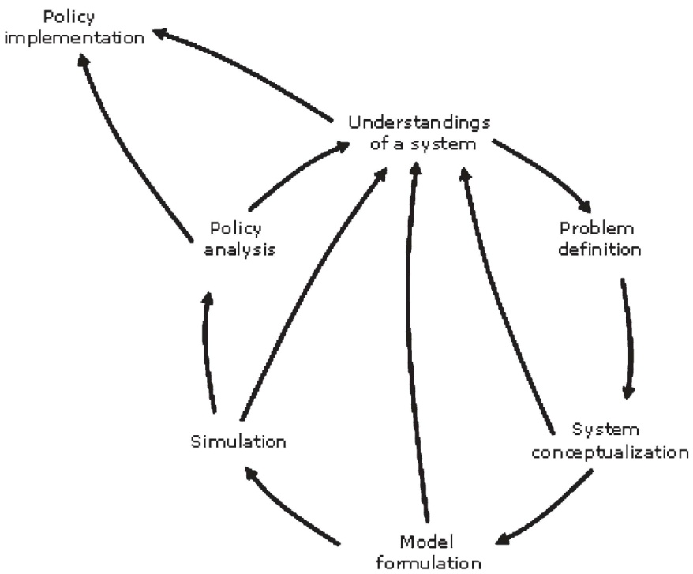
Figure 3.4 System Dynamics Modelling Process [Adapted from Richardson and Pugh, 1981]

They argued that the result of intervention stage should provide a descriptive model, on which SD conceptual feedback structure can be developed. The feedback structural model is developed with the help of a causal loop diagram. The next stage is the conversion of the cause loop diagram into stock and flow diagrams, which is a formal quantitative model of the problem in question. In order to simulate the model, modeler must define the mathematical relationship between and among variables. Simulations can then be run on the important variables. Once confidence is gained, through validation then the model is available to test hypotheses or policies of interest.
Forrester, as founder of SD, in one of his papers “System Dynamics, Systems Thinking, and Soft OR” (Forrester 1994) addresses the six system dynamic steps from problem symptoms to improvement. Forrester in this modeling process, which states from the describe the system and end to Implement changes in policies and structure, accepts systems thinking as a kind of "door opener" for rigorous system dynamics modeling; but he refuses the identification of system dynamics with systems thinking. He believes that the conceptualization phase of system dynamics has much in common with the soft methodologies; however, system dynamics uses explicit models and simulations of dynamic behavior while systems thinking and soft OR lack such a rigorous foundation. However, they can still contribute useful insights from the real-world system and help in the conceptualization phase of building a system dynamics model. Forrester (1994, p.253) notes that defining the problem and conceptualising the system is not only the most critical part of the modelling process, it is also the most difficult one.
As it is illustrated in Figure 3.5, since intervention process starts by observation of undesirable system behavior that motivated the observer to understand and correct it, the steps are carried out in a complete iteration cycle, that is, every step active recycling occurs back to prior step.
Figure 3.5 System Dynamics Modelling Process [Adapted from Forrester, 1994]

- In step 1, the relevant system must be described and hypothesis created for how structure is causing the observed behavior.
- In step 2 the model is formulated using the explicit concepts of SD. that is, the system description is translated the level and rate equations of system dynamics model. Forrester has emphasized that it is the modeling process that generates the most insight about the situation.
- In Step 3 simulation of the model is done. Computer simulation meshes nicely with mental models by taking the mentally stored information and then displaying the dynamic consequences. The simulation should show how the difficulty under consideration is being generated in the real system.
- Step4 identifies policy alternatives for testing. simulation tests determine which policies show the greatest promise.
- Step5 works toward a consensus for implementation which often involves revising deeply embedded policies and strongly held emotional beliefs.
- Step 6 implements the new policies that arise from a relevant and persuasive simulation model and sufficient implementations based on simulation policies.
In short, description of the real world leads to equations of a model, simulation to understand dynamic behavior, evaluation of alternative policies, education and choice of a better policy and implementation.
As a matter of preference, one major system dynamics methodology development, Sterman modelling for learning (2000), is discussed here to captures the main tasks to be performed in an SD intervention. He proposed an intervention process based on the idea that a successful approaches to learning about complex dynamic systems require: (1) tools to elicit and represent the mental models we hold about the nature of difficult problems; (2) formal models and simulation methods to test and improve our mental models, design new policies, and practice new skills; and (3) methods to sharpen scientific reasoning skills, improve group processes, and overcome defensive routines for individuals and teams (Sterman, 2000).
As it is illustrated in Figure 4.6, Sterman emphasizes the iteration of the modelling process and congruence between the virtual world and the real world. The purpose of SD simulation modelling under Sterman’s proposal is to build a flight simulator that can be constantly adjusted to reflect the real world. During the process of reflection, model users can gradually form insights into the real world under investigation, especially unfamiliar issues.
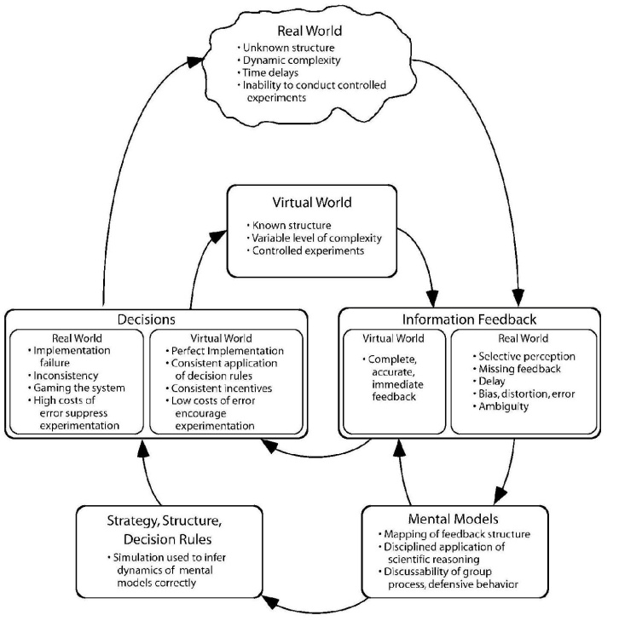
Figure 4.6 Idealized learning process [Adapted from Sterman, 2000]

In the real world (the outer layer) people based on mental models create their strategy, structure and decision rules. However, the learning cycle is complete when they adjust their mental models on the basis of outcome feedback. That is, comparing what was achieved with what was intended. This shows normal trial-and-error approach (Morecraft, 2007). The modelling process as a virtual world which embedded in the larger cycle of learning and action helps people clarify and improve their mental models.
Simulation models are informed by our mental models and by information gleaned from the real world. Strategies, structures, and decision rules used in the real world can be represented and tested in the virtual world of the model. The experiments and tests conducted in the model feed back to alter our mental models and lead to the design of new strategies, new structures, and new decision rules. These new policies are then implemented in the real world, and feedback about their effects leads to new insights and further improvements in both our formal and mental models. Modeling is not a one-shot activity that yields The Answer, but an ongoing process of continual cycling between the virtual world of the model and the real world of action.

3.4.4 The Stages of SD
System dynamics modeling is a feedback process, not a linear sequence of steps. Models go through constant iteration, continual questioning, testing, and refinement. Iteration can occur from any step to any other step. Then it may feed back to alter our basic understanding of the problem and the purpose of our effort.
Sterman, (2000) proposed five steps of modelling process (Figure 3.7) in system dynamics as follows:
Problem Articulation (Boundary Selection)
In this step problem, key variables, and time horizon, should be defined (sterman, 2000); moreover, the subject matter under consideration, its historical behavior, the time window to be considered, and the anticipations for the key factors within the boundary of the study are also determined (Morecroft, 2007).
Formulation of Dynamic Hypothesis
In this step current theories of the problematic behavior is considered at first; then, a dynamic hypothesis should be developed endogenously. Finally, maps of causal structure based on initial hypotheses, key variables, reference modes, and other available data should be developed. A dynamic hypothesis is a theory about how structure and decision policies generate the observed behavior (Oliva, 2003). Problematic behavior of the concerned subject matter is mapped by using tools such as: Model boundary diagrams, subsystem diagrams, causal loop diagrams, stock and flow maps, Policy structure diagrams, and other facilitation tools (Sterman 2000).
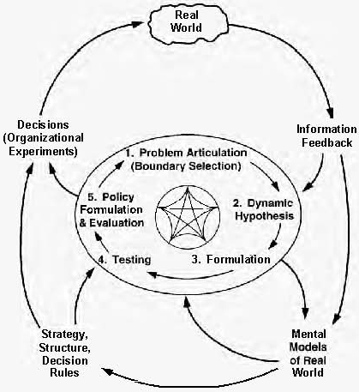
Figure 3.7 system dynamics the modeling process [Adapted from Sterman, 2000]

Formulation of Simulation Model
The decision rules, parameters, initial conditions, the underlying algebraic equations and etc should be determined consistently (Sterman, 2000 and Morecroft, 2007). Listing the equations shows the inconsistencies and gaps in the mapping of the concerned subject matter (Forrester, 1994). The emergence of these gaps forces the modeler to return to step 2. After passing these three steps the model passes the logical criteria, “such as all variables being defined, none defined more than once, no simultaneous equations, and consistent units of measure” (Forrester, 1996). Several computer packages are available to run System Dynamics simulations.
Testing
There are some serious tests which should be done to assure that the model works correctly and effectively (Sterman 2000). The model is simulated in order to see whether it is consistent with the real world or not (Morecroft, 2007). The modeler frequently returns to the first three steps from this step in order to fix the interrelations and equations. Forrester comments that these repeated returns would continue, until the model becomes adequate for the purpose under consideration. Adequacy does not mean validity. Validity of theories that show the behavior of nature cannot be proved as in the example of physics laws (Forrester, 1958). Forrester continues in his comment that only a degree of confidence in a model is achievable, and the best way to do it is by comparing the model with its best alternative which is usually mental models of the people within the real system (Forrester, 1994). If the tests verify that, the model follows the dynamic behavior of the real world situation, i.e. giving the symptoms of the real world problem when creating the same environment in the model.
Policy Design and Evaluation
Finally, changes in environmental conditions (scenarios), policy options and their interactions, and sensitivity of policies under different scenarios should be examined (Sterman 2000). Simulating the model with these policies would allow us to evaluate the expected performance of these policies (Morecroft, 2007).

3.5 COMBINATION OR SYNTHESIS OF SD AND SSM

When explaining methodology always gives examples in using the approach in terms of what it can do to analyse ict impact dynamics
Recently, the epistemological debate eventually moved from the question of selecting a single method to recognizing the value of combining together different methods, not just soft but especially employing both hard and soft methods together that is known as multi-methodology (Mingers, 2000c, 2006; Mingers and Gill, 1997). In the sense that, it is a new method that combines and connects techniques, methods and methodologies from the same, and also different, paradigms of system thinking. (Mingers & Brocklesby, 1997). these combinations system methodologies are aimed at overcoming the drawbacks of many established methods and methodologies. More speseficly, this allows the practitioner to address both the quantitative and qualitative aspects of a complex situation and that different methods can better address the different phases of an intervention (Mingers & White, 2010).
The soft systems methodology and system dynamics methodologies have been previously integrated in different ways. A first start in this direction of thought may be inspired by the interesting papers of Lane & Oliva (1998). However, the most recent articles in this emerging discipline were those of Rodriguez- Ulloa and Paucar-Caceres (2000, 2004, 2005, 2007). Such synthesizing and dialectic methodology, which arose out of a combination of two widely used system-based methodologies is “soft system dynamics methodology”. In each case, the authors stress the need to be critically aware of shortcomings in both methodology and the strong aspects of both paradigms are combined to form a coherent package of methods. It provides an extended perspective. It leverages the complementary aspects of positivistic/representationist and hermeneutic/interpretive perspectives, and allows for combining qualitative and quantitative modeling techniques. Therefore, some of the strengths and weaknesses of two widely used system-based approaches offer an opportunity for dovetailing the two together; the resulting synthesis being an approach which links the two in a mutually supportive way (Lane & Oliva,1998).

3.5.1 Holon Dynamic
Lane and Oliva (1998) discuss the theoretical case for integrating system dynamics and soft systems methodology and the relative strengths of each. They try to bind some of the tools and methods of SD and SSM within a single social theoretical framework. First of all, for the practical value of the synthesis, they show that the proposed synthesis is conceptually coherent by concentrating the conceptual assumptions of the two approaches. Thus they presented an intervention approach as consisting of tools, techniques, method and theory. For presentation purposes, and to facilitate comparisons between methodologies, they group the methodological activities into three distinct phases:
- Finding out about the problem situation;
- Model building;
- Using the model in the problem situation.
For more shed light, their comparison of SSM and SD are summarized in Table 3.2.
Table 3.2 Lane and Oliva’s (1998) comparison between SSM and SD
SSM | SD
1. Finding out about the problem situation.
-The intervention process starts by scrutinizing the structure, The observations at this stage are normally expressed diagrammatically in a ‘Rich Picture’ that focuses on the main relationships, tasks and issues in the problem situation.  -A second line of inquiry is initiated to explore its cultural dimension. | -The intervention process starts by problem definition. The problem behavior is identified and described in a reference mode. Causal factors are identified. Information feedback relationships between factors is framed and. dynamic hypothesis is developed. Along with the dynamic hypothesis, a careful study of the decision making process is done in the initial stages of an SD intervention.
2. Model building.
-Building a variety of models, each representing a particular woridview which considered relevant by some agents in the problem situation. A model of purposeful activity that could, in principle, is enacted in the real world by humans. | -The model is formulated using the explicit concepts of SD (formulating model as rates and levels). A computer-based model is developed.
3. Using the model in the problem situation.
-comparing each model with the real world situation that has two outcome:  1) More potentially relevant systems to be modelled are detected  2) A number of changes (‘systemically desirable) to the problem situation are identified. |  | policy analisis with using the model:  Once the model has satisfied basic validity tests, it is treated as an abstract representation of the actual physical and information flows in a problematic system, and it is used to derive recommendations for policy or structural changes.
implementation

The distinctions made by these authors come close to meeting the need raised from limitations of each one—to deal with both the content and context of an issue synchronically.
They propose a synthesis of the two approaches which is theoretically coherent, and they claim that their synthesis has three aspects, based on the three limitations identified:
- The generating multiple perspectives on a problem and studying them carefully;
- the socio-political aspects of an intervention;
- dynamic coherence of the holon’
First two areas, what it is perceived as a limitation to SD can be overcome by a strength of SSM and in the third aspect SD can contribute to SSM. The three limitations are summarized in Table 3.3 (for more dilates see the Lane and oliva, 1998, p 226):
Table 3.3
SD | SSM
dynamic coherence limitation:  The value of an SSM intervention lies in the systemic nature of the process that has been used to identify the changes. However, changes may implicitly be contradictory, conflicting, self-defeating or ineffective when implemented in a setting with detailed and dynamic complexity. That is, it is weak in ensuring dynamic coherence: consistency between the intuitive behavior resulting from proposed changes and behavior deduced from ideas on causal structure. the missing property of structure/behavior dynamic consistency | Assumption of established problem or issue:  The theory of SD modelling places considerable emphasis on the need to have an issue or problem at the core of the process. Yet the SD literature offers very little comment on ways of eliciting, creating and examining different issues around which a model should be focused. The failure to do this is surely a limitation to the effectiveness of any intervention in a social system.  Lack of socio-political theory:  There is no theory for facilitating sensitivity to socio-political elements. an intervention needs to see problems as entities that are intrinsically embedded in a social context and which cannot be separated from them.

These authors ascertained a lack within SD of theories for generating and representing diverse issues and for enhancing sensitivity to socio-political aspects. They present a scheme in which logic-based analysis is complemented by an extended cultural analysis, which is supposed to comprehend what they call analysis of the intervention, social system analysis, and political system analysis. They developed a framework for intervention into complex systems, named “Holon dynamics”.
Lane and Oliva (1998) drew a rich picture diagram of the proposed synthesis of SSM and SD. As it illustrated in Figure 3.8, after an initial SSM intervention - by which proposed changes are identified - a second stage takes place. This continues the socio-political analysis and draws on the previous worldview. It operates within a new worldview which values dynamic consistency of the holon which is able to represent the proposed changes. A model of this holon is constructed using SD to represent causal structure and to deduce behavior. Using SD methods, the changes are thus rendered systemically desirable in the additional sense that dynamic consistency has been confirmed. Note that it is accepted that some proposed changes will not require SD analysis; these skirt the second stage, as indicated.
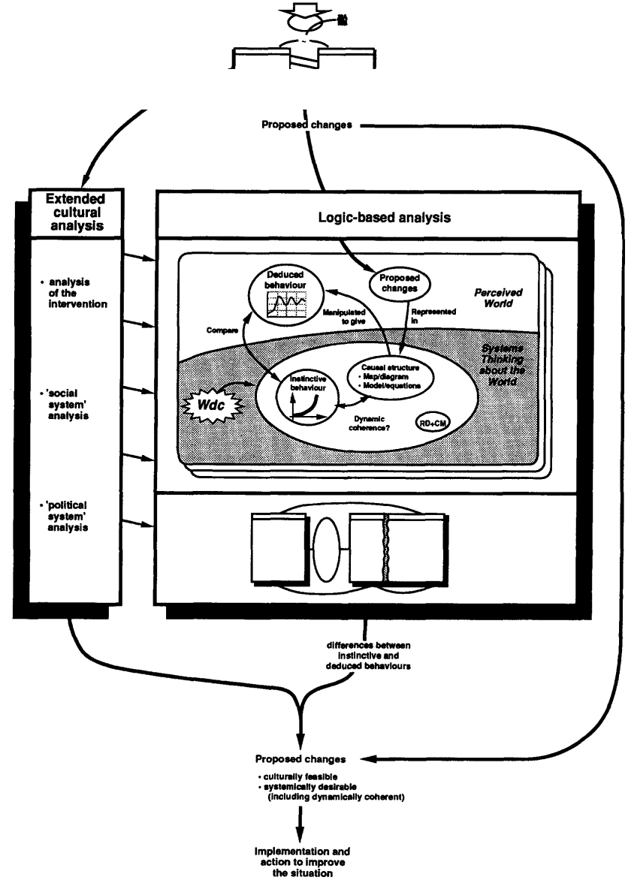
Figure 3.8 Rich picture diagram of the proposed synthesis [Adapted from Sterman, 2000]

The cultural stream is extended in parallel with a new logic stream. In the latter, they take their study further by identifying the holon which they perceive as having a causal structure in which they can represent the effect of their proposed changes. This process may be aided by their revisiting a sub-set or fragments of their previous holons as well as their generating new ones. It may result in one model or a set of different models, representing different holons. Whatever the case, the focus for this activity is wordview dynamic coherent, the issue of the need to test for dynamic consistency, a property now desired if they are to believe that the changes that they have identified, and which they believe will improve the real world system when implemented, will indeed yield desirable behavior when set within their causal structure assumptions about their holon. They make representations of this holon (or holons), perhaps using SSM tools again but certainly by using the methods of SD.
The causal structure is diagrammed and then represented as a simulation model (or models). The intuitive behavior of the appropriate variables is elicited and represented. The model is simulated (manipulated) to produce the behavior which is a logical deduction of both the causal structure and the effects of making the proposed changes. These runs are then compared with the intuitive behavior. Mismatches are debated and may result in new proposed changes which are, in turn, represented in the causal structure model so that the behavioral consequences can be deduced. A process occurs in which changes, model structure and intuitive behaviors are all experimented with and adjusted appropriately. This is an iterative process of team learning. Its result is the identification of a finalized list of proposed changes, a list in the minds of the members of the group and also in the real world. These changes are now dynamically coherent because the team’s intuition (in the minds of the members of the group) about the holon behavior that would result from implementing the changes is consistent with the behavior that can be deduced by representing the teams’ views on the causal structure of the holon.
According to lane and Oliva (1998) “this is an epistemological stance, concerning the nature of the enquiring process and does not disturb the over-arching relativist ontology (p229).” The epistemological stance and the boundaries of the proposed synthesis have been thoroughly developed, but the procedure outlined needs further operationalization (Schwaninger, 1996).

3.5.2 Soft System Dynamic Methodology (SSDM)
SSDM was developed by Ricardo Rodrı´guez-Ulloa and his colleagues from the Institute Andino de Sistemas (IAS) inLima, Peru, in a real-world action research project conducted by IAS between 1992 and 2000, in a collaborative effort with private and governmental organizations in Peru and other Latin American countries.
In consequence of a long range research project under the direction of Ricardo Rodriguez-Ulloa on the strengths of the system dynamics modeling, he reported that the SD’s practitioners faced with serious questions which raise from certain limitations embedded in the SD’s assumptions to model and confront in diverse problematic situations. “His research posed, among others, the following questions (Rodriguez-Ulloa & 2011 p):
- Under which worldview are the SD models built when they approach specific phenomena from the real world?
- Who is the observer, and why does he/she observe the real world under a specific and chosen worldview?
- What types of interest and values lead the observer to observe the real world under a specific worldview?
- How can a ‘‘solution’’ be provided if the observer has not clearly comprehended the problematic situation (i.e., he/she is defining a ‘‘problem,’’ not a ‘‘problematic situation’’) or is unaware of the worldview under which the problematic situation is being observed?
- Are the ‘‘solutions’’ of the system dynamics approach culturally feasible and systemically desirable?
Thus, the experience of Rodriguez-Ulloa and his team at IAS in the use of SSM in the Peruvian reality (Rodrı´guez-Ulloa 1988, 1990, 1994, 2001) led to some of the basic concepts, stages and philosophical principles of SSM being incorporated into the SD approach, in an attempt to answer the previous questions concerning SD, but without removing aspects of great use and potentiality shown by SD.
SSDM is acknowledged that contribution lies on in the elucidation of a methodological framework, where the principles, concepts, philosophies, techniques and technologies from both sides are taken into account and put them to work together. The ontological, epistemological and methodological premises underpinning SSDM and its constituents, SSM and SD have been discussed based on Rodr´ıguez-Ulloa (1999, 2004) and Mingers (1997b). As the founder SSDM emphasizes this methodology constitutes a new and creative intellectual framework for the analysis and design of social systems that has emerged from combining some of the stages of both methodology.
Unlike Lane and Oliva propose, Rodriguez methodology (SSDM) presents clear ten stages (Figure 3.9) and 2 systemic loops which forces the practitioner to visit SSDM ‘three worlds’: (i) Real World (SSDM’s World 1); (ii) Problem–Situation-Oriented Systems Thinking World (SSDM’s World 2); and (iii) Solving–Situation-Oriented Systems Thinking World (SSDM’s World 3). The first loop deals with the 'problem situation-oriented systems thinking world' and the 'second loop' deals with the 'solving situation- oriented systems thinking world'.
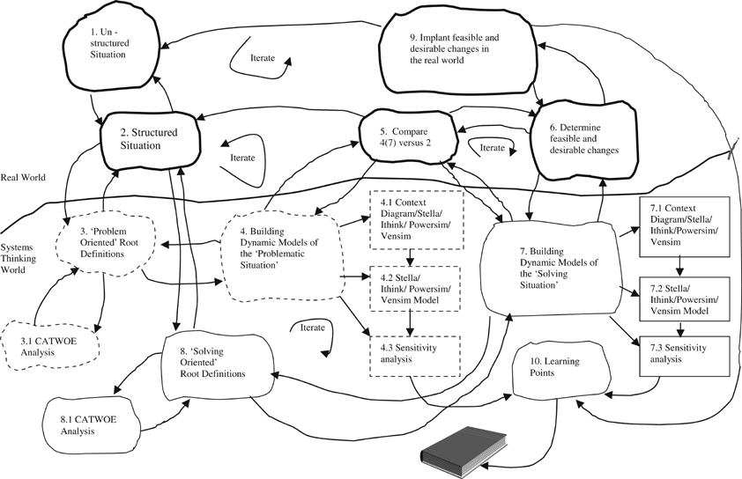
Figure 3.9 Soft Systems Dynamics methodology (SSDM) [adapted from Rodr´ıguez-Ulloa, 2005]

Rodriquez-Ulloa and Paucar-Caceres (2004) highlights the advantages of the combined use of SD and SSM under the SSDM framework, the main being: (i) It introduces explicitly the observer’s weltanschauung and the observer’s role in SSD studies; (ii) It proposes and allows to implement desirable and feasible changes in the real world; (iii) It allows, through the computer simulation over time, to measure and asses the kind and intensity of impacts, due to the behavior of the variables studied in the problem situation (Stage 4) as well as in the solving situation (Stage 7); and (iv) It allows to analyze n different possible interpretations on the ‘problematic’ and ’solving’ behavior of a situation in the real world.
Table 4.2 lists the stages and summarizes their descriptions that used in SSDM.

Stage | Title | Description
1 | Unstructured Problem Situation | Identifying and analyzing what is happening in a portion of the real world in systemic, phenomenological, hermeneutic and epistemological terms. | Real World (What real world?)
2 | Structured Situation | Understanding and expressing all aspect of problematic situation graphically in the rich picture.
3 | Problem-Oriented Root Definitions | Expressing the problematic transformation process that it is assumed to occur in the real world. | Problem-Oriented Systems Thinking World
4 | Building Problem-Oriented Dynamic Models | Modeling the structure of each root definition of a problematic situation based on a particular W in terms as usually SD expresses the phenomena occurring in the real world.
5 | Compare stage 4 (stage 7) against 2. | comparing the problem-oriented conceptual model, SD context-diagram and SD models with the rich picture built up at Stage 2 | Real World
6 | Determine culturally feasible and systemically desirable changes | looking to obtain culturally feasible and systemically desirable changes in terms of which variables and causal relationships must be removed, changed, and/or added in order to improve the problematic behavior of the situation.
7 | Building system dynamics models of the 'solving situation'. | building a SD context diagram of the solving-oriented approach to be implemented in the real world and going to the subsequent SD causal loop modeling details and performing a sensitivity analysis to observe the outcomes according to the variations of the causal variables and/or their causal relationships. | Solving-Oriented Systems Thinking World
8 | Solving situation-oriented root definitions | expressing the transformation process needed to implant ‘improvements’ in the problematic situation in SSM terms
9 | Implementation of feasible and desirable changes in the real world. | doing with the implementation Culturally Feasible and Systemically Desirable Changes in the Real World | Real World
10 | Learning points | Collecting and saving for study and occasional reflection, thinking in apply them in future interventions as learning point which come from the analysis of the stages 4, 7, 9. | Solving-Oriented Systems Thinking World

COMMENTS
Discuss the strength and limitation of the existing Lane and Oliva (1998) drew a rich picture diagram of the proposed synthesis of SSM and SD. As it illustrated in Figure 3.8, after an initial SSM intervention AND SSDM (Figure 3.9 Soft Systems Dynamics methodology (SSDM) [adapted from Rodr´ıguez-Ulloa, 2005] in developing ICT impact dynamic model as such you need to further improve the approach to modeling ICT impact dynamics and propose new one?

3.6 CONCLUSIONS
Write the conclusions of the chapter

