Applying System Thinking to Model Socioeconomic Complexity and Dynamic for Economic Development Planning

Mohammad Haghshenas
haghshenas.info@gmail.com
Associate Prof. Dr. Hasmiah Kasimin
miah@ukm.my
Faculty of Economics and Business, UKM

Abstract
More recently, the field of System Thinking has been applied widely to socioeconomic modeling and problem solving. So, this paper is originated by the idea to investigate the contributions of System Thinking approaches to economic growth modeling for national planning. The economic modeling faces with some challenges specially for modeling complexity and dynamics of social and environmental aspect in development planning. The issue has grown in the key concept of Systems Thinking methodology that views a system holistically rather than partial analysis as it is common in most traditional analytic methods. In order to understand how the System Thinking approaches can be applied in the process of growth modeling, the structure of two basic growth models namely Harrod-Domar and Solow are translated in the System Dynamics language. Then by considering a wide variety of soft variables of social and environmental sectors, the growth model was improved. This process showed that System Thinking approach and System Dynamics modeling can contribute to model economic development and consequently better understanding of socioeconomic complexity and dynamic that goes beyond what traditional models are able to do.

Keywords: System thinking, Soft Systems Methodology, System Dynamics, Economic Dynamics, Economic Growth Model, Feedback method.

JEL: O21

1. Introduction
In order to improve the quality of life, most of the countries seek to plan economic development strategies. However, from the beginning of this century, the world is experiencing a wide variety of increasingly complex, dynamic problems. Therefore, it gives rise to the dynamic complexity in growth and national planning too, which must take into account the interactive and integrated nature of economics, society, and environment. If planning does not consider the links between them, opportunities will be missed for yielding the desired results within a long time and in its turn, it determines a growing need for improving analytical support tool, which allows policy makers to test the dynamic responses to policy making.
Traditionally, most modeling process in economic phenomena analyses typically applies mathematical and statistical techniques. So far, however, there have been little discussions about limitations and challenges with each method for modeling an economy in national planning. Moreover, economists must remember that one of their missions is to reach out to growing methodological fields and bring them within the field’s community and toolkit (Benaroch, 1996). The field of System Thinking is a potential methodology and System Dynamics modeling has been applied widely over recent decades as it has attracted great attention from universities to government organizations for growth modeling and national planning. This paper will focus on the System Thinking contribution in economic growth modeling and national development planning.

2. The functions of economic model for macro policy and planning
Most of economic models in the macro level such as Keynesian or neo-classical growth models, the social accounting matrix, the general equilibrium model and so forth deal with predicting and growth assignment. As Howitt (2002) claimed, an economic planner can conduct three tasks with economic models: interpreting the observed actions; forecasting economic phenomena; controlling or affecting certain economic outcomes. In such a way, economists and developmental planners create models to find out the result of change, to compute the growth impact and to predict the needed resource (Kooros & Badeaux, 2007).
Although, macroeconomic models can be a powerful tool for forecasting and policy analyses, their significant contribution is in assisting to deeper understanding of dynamic behavior in complex economic phenomena or system. Dynamics of a system are characterized by changing variables over time as they interact together. Since, the causes and effects links involve time delays or basically, actions and reactions are detached in time and place it is hard to predict changes (Barlas, 2009). In fact, the most complex behaviors usually are not from the complexity of the components themselves, but they arise from the interactions (feedbacks) among them (Sterman 2000). Furthermore, most dynamics phenomena are non-linear which can generate a wide diversity of complex patterns of dynamic behavior. In this respect, as the amount of components in a situation increase, the complexity of the components increases nonlinearly. More importantly, since typical economic phenomena involve human actors, the human dimension itself adds an extra level of complexity (Barlas, 2009). In conclusion, one of the main reasons that a planner creates macro-models for national or regional planning is to understand and capture complex and dynamic interrelationships among variables at the macroeconomic level where everything relates to everything else.

3. Some challenges with economic models and methods
As all economists know, the economy is very complex; that is why they try to simplify that complexity as much as possible and make it understandable by formal structural analytic model (Colander, 2008). Conventionally, the majority of applicable economic models are based on the theoretical foundation to understand economic behavior and mathematical equations for formulations of economic theories and/or use statistic method (econometrics) to explain economic phenomena and also to forecast economic variable changes or behavior based on policies. On the side of theoretical foundation, economic theories mentioned in standard textbooks are quite normally under the neoclassical economic assumption that is a static model of free markets (McCauley & Küffner, 2004). However, in macro level where major concern on economic theorists has been economic growth, policy measures can only be discussed and understood accurately with the help of a model as an important instrument which sets out the key relationships between the macroeconomic variables. (Don & Verbruggen, 2006).
Generally speaking, the economic modeling methods have two boundaries; one end refers to the ideas of economic theories, and the other one cohere to empirical data (Pagan, 2003). For instance, Computable General Equilibrium (CGE) model is based on microeconomic laws - a demonstration of the demand and supply systems through competitive market mechanisms - to simulate an entire economic system to direct to macroeconomic analysis (Little 1995), while, Vector Autoregressive (VAR) models have been used widely in empirical studies for studying macroeconomic aggregates for predicting, policy analysis, and interpreting time series (Sargent & Sims, 2011). All these modeling methods helped policy makers greatly to think about development and investigate the potential effects of various policy alternatives. Moreover, reasonable restrictions on the movement of different variables as well as their probable behavioral actions can be signified by them. However, they have a number of limitations.
Initially, as development economists aware of the models at the degree of theoretical coherence, simply cannot apply in developing economies, since they are based on perfect market assumptions that can be found in developed economies just approximately. Thus, one common observation of growth in developing economies is that markets are rarely in equilibrium and there is no tendency to equilibria as well (Shilling, 2003). In this case, the equilibria are not ruled in their markets so it is difficult to use models based on pure theories. Thus, this in itself identifies a series of conflicts faced by development economists.
Furthermore, the models at the degree of theoretical coherence only become applicable when the behavioral relationships in them are practically quantified by applying econometric techniques based on real data. Therefore, long time series of historical observations is necessary to do so. In this respect, insufficient availability and quality of the required data in developing economies play a major role. In the sense that the models will not be evaluated mainly on the properties of its statistic techniques. Consequently, one of the significant challenges in this case is the model builder is faced up to a trade –off between the policymakers’ desires, theoretical economists and econometricians (Don & Verbruggen, 2006).
An additional limitation of economic modeling is the fact that some of them although are based on economics’ behavioral theories, are the results of a mathematical algorithm not a specific behavioral procedure, so these models tend to be ‘black boxes’ (Shilling, 2003). In the real world, as the complexity of economic is more than its constant feature to be reflected in a simple set of equations, a solution cannot be provided by more complex models and declines to a black box model when the why and what of the model’s outcomes are not understandable (Don & Verbruggen, 2006). In addition, as mentioned before the socioeconomic phenomena involve human dimensions and non-linear feedback interaction between variables that increase the complexity of phenomena. It implies that at even small size economic policy problems, which involve more than ten variables, a non-linear feedback system seems hard to track both mathematically and intuitively (Barlas, 2007).
Having said this, a lot of economists have recognized these problems to find proper ways to be advised to developing countries. However, it is difficult to do so in the context of conventional models and theory (Shilling, 2003). Obviously, selection of the best model to do research is an art in order to balance the requirements of realism which complicate the model and pragmatic solution based on the data and computational requirements. Economic policy models not only must be simple enough to what extent that the decision maker can recognize the model concept, but also be manageable and able to replicate the data (Howitt, 2002).
One of the most significant current challenges in economic modeling methods is “soft” (unmeasured) variables as well as unstructured problem situations. Forrester (1961), founder of the System Dynamics methodology, and Sterman (2000) argued that variables are not only numerical data, but if soft (unmeasured) variables are significant to the purpose should be included in our models. For instants, total production in the economic growth of a country would depend on many soft variables other than the traditional variables of capital and labor such as social and environmental factors. Although classical economics has addressed a majority of limiting factors in political, social, demographic and environmental domains, have often been ignored in the mathematical tradition of neoclassical models, because this factor deals with soft variables that are not easy to quantify but at the same time have significant effect on behavior of the economy (Saeed 2005). Omitting important structures or variables due to unavailability of numerical data is, in fact, less scientific and precise than applying the best evaluation to estimate their values (Sterman, 2002).
The last not the least, in the most socioeconomic systems there are many unstructured problem situations and major challenge for the policy makers is better to understand what is happening in the real world. Then, the need for solving unstructured and messy problems led researchers to search for flexible models, considering “softer” models would better signify various points of view to fulfill this need (Graeml and et. al, 2004). Hence, better understanding of complex systems may involve the models that are useful in addressing dynamic and unstructured problem. This modeling approach is useful to engage human beings, and offers a conceptual model for existing structure in the real world (Wit, 2011).
All in all, the macroeconomists and growth model builders mostly have concentrated on mathematics applicable and statistical techniques through a series of restricted models. Nevertheless, that approach in complex and dynamic real-world with the recent fast changes does not work well. The present study deals with Systems thinking paradigm that is capable to provide a different perspective on economic and development issues as an alternative that focuses on a better understanding of a complex and dynamic of the system which often concerned with the human aspects.

4. Systems Thinking and Its Prevalent Approaches for Modeling Complex System
The modern world in the 21th century is involving in a wide variety of growing complex and dynamic problems situation that System Thinking paradigm can contribute a better understanding and solving them.
Generally speaking, “The core systems idea or concept is that of an adaptive whole (a ’system’) which can survive through time by adapting to changes in its environment" (Checkland & Poulter 2010, p 202). In this respect, it implies interaction and interdependence (Forrester, 1961). As Checkland and Poulter (2010) also argued survival of a system through time needs communication processes, control processes, a layered structure and emergent properties of the system as a whole. Regarding this concept, the process of understanding how things interact with each other within a whole is the key concept of Systems thinking. Checkland (1991) declares that this idea has been formed duo to three problems in science: “complexity in general, the extension of science to cover social phenomena, and the application of science in real world situations” (Checkland, 1991, p74). Additionally, Manni and Cavana, (2007) believed this is a scientific filed of knowledge that involves the study of dynamic cause and effect over time to identify and understand changes and complexity of phenomena.
When we look at all the different fields of system approach, a similar picture has emerged (Rees, 2000). However, systems thinking approaches are classified into 'hard' and 'soft' approach. Although, there are basic differences in the two (hard vs. soft) approaches, both Soft and hard systems methods are used to solve real-world problems (Ekasingh & Letcher, 2008). Often, there is confusion on the value or importance of hard and soft system approach in system thinking. Checkland (2000) provides interesting perspective of hard and soft systems as follows:
- Hard system approaches are based on the assumption that the world is a collection of interacting systems, and we can engineer the one which do not work very well in order to work better.
- Soft system approaches are based on the assumptions that the world is taken to be very complex, problematical, and mysterious. However, by the process of inquiry into it, it can be organized exploration as a learning system.

For the more shed light, hard systems involve simulations often with computers and very helpful in dealing with problems and objectives can be well defined. Soft systems on the other hand, deal with problems that cannot simply be defined and useful for engaging human beings and existence point of views in the real world. This approach focuses on a better understanding of complex systems by an iterative learning process (Wit, 2011).
In the world of System Thinking studies, there are some attempts to combine soft and hard System Thinking approach and create a multi methodology approach to overcome the limitations of each other. For example, soft systems dynamics methodology arose as a mixture of System Dynamics and soft systems methodology as two well-known methodologies in the systems movement: developed by Rodriguez-Ulloa and collogues (2005.., 2007, 2011). He believed that the systems dynamics methodology overcomes the pitfalls of soft systems methodology by including System Dynamics to its scaffold.
System Dynamics modeling is an effort to deal with increasingly complex and dynamic problems and appeared as a popular and powerful tool for understanding, simulating and analyzing real world. In this approach models are the result of linking the relevant parts of a system’s structure and simulating the behavior created by that structure. Through an iterative process system’s problematic behavior can be identified and serve as a tool for policy design and testing (Radzicki, 2011). Even if the real world demonstrates a large amount of complexity, it can be verified in a System Dynamics model (Mildeová & Němcová, 2009). Today, System Dynamics modeling interest is growing quickly because it can address the basic structural causes of the long-term dynamic modern socio-economic problems (Barlas, 2002). In addition, this method provides cheaper learning and faster experiment on a virtual model with the effect of new policy making than on a real system with real society, processes, and equipment (Harris, 2000).
Putting all together, it can be concluded that the System Thinking approaches aims to understand and structure complex problem situations, to clarify point of views and stimulus, to deal with both qualitative and quantitative aspects of the situation, to solve real-world problems, to develop impact evaluation, to simulate the system behavior, and to design and test policy making. Moreover, to get better result we can integrate “soft” and “hard” systems methods to improve the significance and strength of the models to dynamic modern socio-economic problems, specially it is a powerful tool for economic growth and development modeling.

5. General Structure of the Growth in System Dynamics Modeling Protocol
Forrester (1961) created a language to portray the dynamics of system which include four tips or blocks: Stock, Flow, Variable and information Arrow. Stocks accumulate (i.e., sum up) the information or material that flows into and out of them. Mathematically, stocks is called integration and a system’s flow equations are ordinary differential equations (Radzicki, 2011 ). In simple concept, Flows can be thought of as pipe and tap assemblies that fill or withdraw the stocks. Stocks can be thought of as bathtubs that accumulate or de-cumulate a system’s flows over time. Auxiliary variables submit an application the computation between stocks, flows, constants and other variables. This is a very smart idea for portraying structure of a system, not important how big it is, all we need to know is four building blocks or scripts and their simple language rules.
Meanwhile, the feedback concept, information loops and causal circular, is at the heart of the System Dynamics and it is an implement for conceptualizing the complex system structure (Meyers, 2009). Two fundamental type feedbacks exist in System Dynamics; reinforcing (exponential or positive) feedback which generates growth behavior and balancing (negative) feedback which generates decline behavior. From a System Dynamics perspective, reinforcing and balancing feedback loops fight to manage behavior of a system (Radzicki, 2011). The integration process creates all dynamic behavior in the world being in any system such as an economic system.
For general structure of growth, by referring to the exponential growth we find that: a Stock K changes during the time in order to the amount of inflows and outflows through feedbacks process of stock per time t; ∆K = K t – Kt-1. The exponential growth path depends on a certain indicator multiplied so the net change of ∆K becomes: ∆K= Kt-1 * n if n>0, a certain share of the stock K causes an increase (Weber, 2007).
The basic structural growth in figure (1) represents the simplest growth structure which have two feedbacks simultaneously in System Dynamics language.

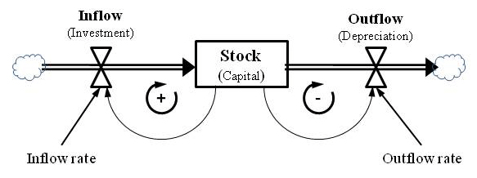

Figure 2: Basic economic growth structure in System Dynamics language

As it is conceptually illustrated in Figure 2, the rectangle represents stock of capital which is determined by the changes in inflow of investment and outflow of depreciation. Inflow and outflow indicates the change in the level of stock from t to t+1. In addition, in the middle of the loop sign of “+” shows the total effect of a loop reinforcing feedback and sign of “-“ within the total effect of the loop is balancing feedback.
Structurally, in the feedback stock-dependent relation, flow(s) itself is affected by the existing amount of stock which through a feedback loop can cause the next amount of flow. In other words flow is a function of stock as previously mentioned:
∆K = K t – Kt-1

The left side of diagram illustrates the capital growing as long as positive inflow fraction rate and provide a process of exponential growth and the right side of diagram illustrates the capital diminishing as long as positive inflow fraction rate is identified by depreciation period and provide a process of exponential decay. It is clear that when inflow fraction is larger than outflow fraction, the system generates growth behavior exponentially and vice versa.
In general, the growth model structure determines the behavior and same structures cause similar types of behavior. Yet we will see that the simple exponential basic structure can be retrieved in all introduced growth models.

6. Basic Economic Growth Models in System Dynamics Modeling Protocol
System Dynamics methodology is compatible with conventional economic approaches with the aim of modeling dynamic phenomena (Smith & Ackere, 2002). In the sense that this method integrates features that make it useful for understanding dynamic of growth and is able to model the effect of information feedback on the future direction of growth model (Lechón & Torres 2010). In addition, for economic modeling, System Dynamics is applied through three ways: translating an existing economic model into a System Dynamics framework; generating an economic model by following the System Dynamics paradigm principles and rules; modeling as a “hybrid” approach to mix the advantages of the first two ways (Radzicki 2011)
Here, based on the simple basic structure of the growth model, we investigate the dynamic of two existing well-known economic growth model: Harrod-Domar and Solow models. These two basic Keynesian and Neoclassic models consider limited factors of production. While, by adding a wide variety of factors including more soft variables than traditional variables of capital and labor such as social and environmental factors in the growth model we can expand it. Although, it seems complexity of the system will increase dynamically, System Dynamics modeling can analyze it.
The Harrod-Domar model is the economic growth feature in the Keynesian macroeconomic approach. The major Keynesian equations for determining a macroeconomic equilibrium is given by Yt = Ct + St or Yt = Ct + It. The first equation shows us that national income Y is divided between consumption C and savings S. The second equation declares that total output is composed of both consumption and capital goods (investment I). Then in the simple macroeconomic equilibrium condition investment is equal savings It = St.
Savings are supposed to be a linear homogenous function of national income, so: St = sYt. Investment is function of the change in capital stock K so:
It = ∆Kt = sYt

As in the Harrod-Domar model, it is assumed capital-output ratio, k, is equal to total capital stock per total national income:
k = Kt/Yt
then:
Kt = kYt or ∆Kt = k∆Yt

As mentioned above, the accumulation of capital stock K creates dynamics of the economic growth models, then changes in the capital stock comes from investments and the depreciation: K t+1 = (1-∂) Kt + It that ∂ is depreciation rate, then:
kYt+1 = (1-∂)kYt + sYt

∆Yt/Yt is equal to the rate of growth of national income (the percentage change in national income):

g =(Yt+1 – Yt )/Yt
Then:
g= $\frac{s}{k}$ $–∂$

Harrod-Domar model of economic growth states that: The rate of growth of national income, g, is determined by the national saving ratio, s, and the national capital-output ratio, k, and the national depreciation rate, ∂.
Therefore:
1) The growth rate of national income is positively related to the savings ratio, i.e., the higher an economy is able to save – and therefore invest, the greater will be the growth of that national income.
2) The growth rate of national income is negatively related to the economy’s capital-output ratio, i.e., the more is capital-output ratio, the lower is the rate of national income growth.
Now let’s look at the Harrod-Domar model in System Dynamics method. The structure of the Harrod-Domar model in System Dynamics language is shown in Figure 3. The diagram represents three major features of the model that can be easily recognized: it shows the inflow of investment and outflow of depreciation and the stock of capital that alter by those flows; the economic growth rate is generated by the reinforcing feedback loop in the diagram; more stock of capital results in a higher production that leads to a more savings that leads to a higher inflow of investment, and finally boots the stock of capital. On the other hand, growth rate tends to be balanced by balancing feedback loop, so, more stock of capital leads to higher outflow of depreciation that descends the stock of capital.
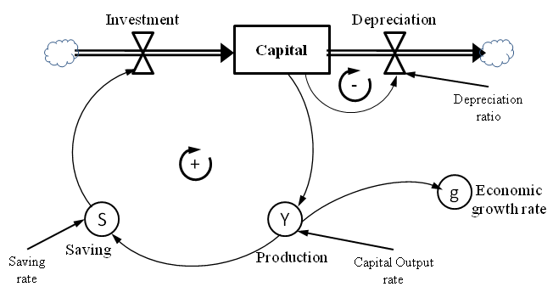

Figure 3: Harrod-Domar model in System Dynamics language

Although Harrod-Domar mathematical equations include all the data shown in the diagram, the dynamic is rarely understandable by equations, while existing capital stock and feedback loops in the model make it comprehensible. Now in order to analyze dynamic of the simple growth model one of the System Dynamics contributions is that we don’t need to know advanced mathematics and actually this visual model can help us to provide answers to a vast variety of "what-if" questions. To do this, we apply special software to stimulate economic growth model and compare the time path of economic growth under different conditions (Figure 4).
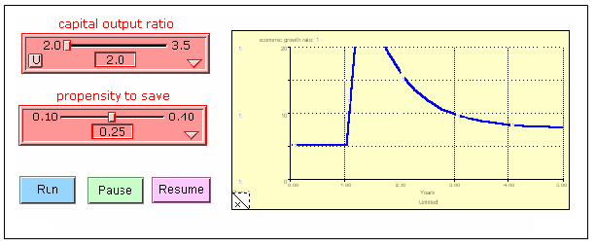
Figure4: The behavior of the model when diminish in rate of the capital-output-ratio because of enhancing in technology, lead to the annual growth rate to rise. (basic model in iThink software)

The neoclassical growth model is known Robert Solow (1956) model. Solow’s growth model shows that there are two factors that help to produce output: capital and labor. Technology is exogenous and represented by a production function (Solow, 1956):

Y = F(K,L)
If it is assumed that total output or production Y is a Cobb-Douglas function with the production elasticity Alpha, the equation consists of three key factors: the capital stock K, the supply of labor forces L, and finally the technical variable A.

F(K,L) = A$K^{α}L^{α-1}$
Figure 5 symbolizes the structure of the Solow-model in System Dynamics language to explain how capital accumulation growing, labor force growing based on population exponential growth pattern and technology progress interact and affect economy’s total production. Like the above mentioned basic growth model, the capital stock equation is the most significant equation that illustrates how capital accumulates. Where in a closed economy, investment is equal to saving and a constant share of income is saved, investments change the capital stock over time. The labor force and the technological grow exogenously but labor force includes population exponential growth patterns.
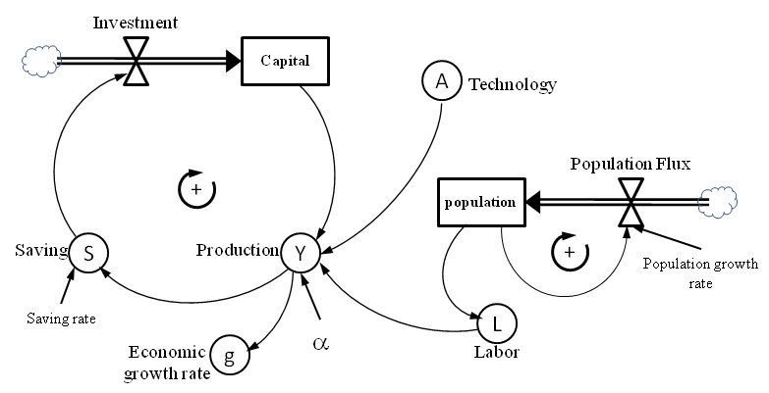

Figure 5: Solow model in System Dynamics language

System Dynamics modeling allows us to add soft variables in the formal models and understand the structure of the classical growth models easily (Saeed, 2005).

7. Improving a Dynamic Model for Economic Growth and Development
The Harrod-Domar and Solow models consider only limited factor of production. As we know the production is function of capital, labor, materials and technology but each one includes a wide variety of quantity and quality factors. In other words, an economy total production Y is:

Y = f (K, L, M, T)
Where K represents capital (including agriculture, industry and services capital), L represents labor (including labor productivity, health, education, population and social factors), M represents raw materials (including resources and environmental factors) and T represents technology (including investment, strategy and management).
This simple function shows that economic of a country can be explained by considering a wide variety of factors such as capital accumulation, level of education, population growth, level of investments in research, development and innovation in industries, good institutions, management of the public resources, initial conditions of the economy, fiscal policy, level of international trade, geographical factors, natural resources, governmental consumption, level of infrastructures, and so forth. Nevertheless, in spite of many factors which affect the total production, most of the models of economic growth and development, focus on just a limited number of factors. Adding each factor brings complexity and dynamic processes into growth model.
Traditionally, economists use mathematics often in the form of different equations to develop models of dynamic processes in economics model building, but they believe that the mathematical models in the area of complex dynamic economics are not easy to understand, and also they need to be taught in advanced mathematic level. In addition, they can’t enter quality components easily. In this way, System Dynamics methodology would contribute to deal with the growth model from other perspective than traditional one.
The importance of System Dynamics for economics was recognized from the beginning by its founder Jay Forrester (Forrester, Nathaniel & Charles, 1976). Forrester used System Dynamics modeling approach to create a national model which was designed to public policy analysis. The model was a computer simulation model of social and economic changes in the United States that include six principal sectors namely, production, financial, labor, demographic, household, and government.
Today, a famous comprehensive model of national planning in System Dynamics approach called Threshold 21, developed by Millennium Institute (MI), which is a dynamic macroeconomic model designed to support comprehensive, integrated long-term economic growth and development. The main goal of the model has been to develop a practical model that incorporate a range of issues involved in sustainable development of a country (Barney & Pedercini, 2003). In fact, besides economy (investment, production, row material, technology, households and government); the model must include the social dimensions (population, gender, health, poverty, education, and income distribution) and environment (land, resource stocks, energy, sustainability, minerals).

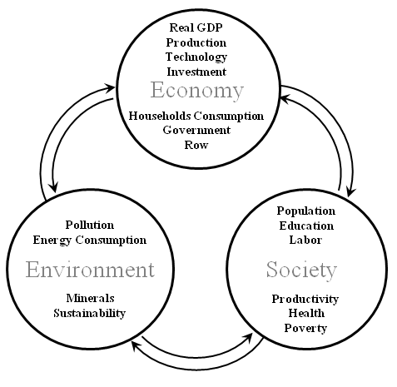

Figure 6: Conceptual view of the cross-subsystem linkages. Source: T21(MI)

Form a simple viewpoint, a high level conceptual view of a dynamic macroeconomic model is illustrated in the Figure 6 with the linkages among the economy, society, and environment subsystems. Within each sub-system are a number of sectors, modules, and structural relations that interact with each other and with factors in the other parts. The dynamic behavior as a simplest form with fewest factors of three subsystems illustrated in System Dynamics language (Figure 7) from which economic subsystem is based on Harod-Domar and Solow models as mentioned earlier.
The Economy sub-system contains major production sectors (agriculture, industry and services) which are characterized by production functions with inputs of capital, labor, technology, and resources. Capital stock that is grown through the investment flow leads to total production and income, in turn, some of which save and invest to generate more capital. Technology also contributes to production loop. This is the most important positive feedback loop that leads to economic growth.
Other loops from the society and environment subsystems are also significant to influence the growth. In addition to production capital stock, the model contains both environmental and social capital stock that in turn have an impact on economy situations as a key and major part of the model. The social and environmental feedbacks through the magnitude of the quality of the labor force, resources and pollution control to influence labor productivity and total production.
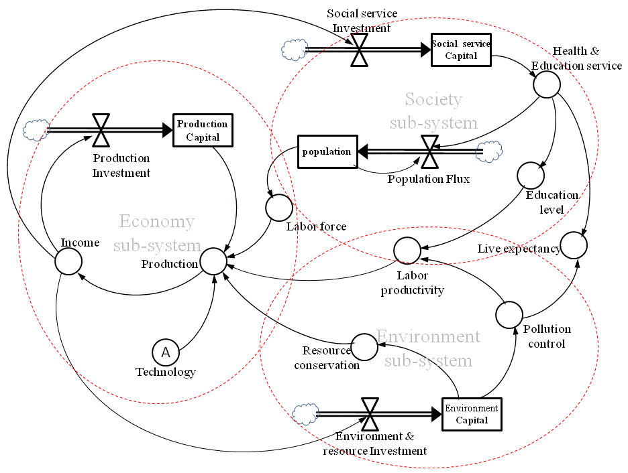

Figure 7: linkages and dynamic behavior of three subsystems in System Dynamics language
The Social feedback loop is based on population dynamics, health and education challenges. Growing in social service capital in result of investment flow leads to health and education sectors which affect population growth. Population determines the labor force, which shapes employment as a key resource for all production activities. Education and health levels, together with other factors, influence labor productivity that affects total production from a given capital stock of production sectors. The health and education levels also increase life expectancy.
As a final point, by expanding the environment subsystem it is clear that how investment can be made in resource conservation and pollution control. Resource conservation determines the consumption of natural resources and can determine the impact of the depletion of these resources on production or other factors. Resource availability influence production. In turn, production influence pollution and pollution influences health. On the other hand, available advanced technologies apply resources in more efficient way thus it reduces generated pollution through production processes and affects labor productivity and life expectancy.
This process also deepens understanding of development challenges in the different sectors and how they interact, so that planners can explain better what is likely to happen, and why. This structure and behavior model might include more sectors and more factors that are detailed. In economy subsystem, this model can contain government, household, foreign exchange, banks, and technology as endogenous sector in addition to production and investment sectors. In society subsystem, it can contain labor, population, health, education, poverty, and infrastructure. In environment subsystem, it may contain energy, land, waste generation and products, emissions and so on.
At the end, it is worth to recall, “System Dynamics models can represent phenomena in ways that go beyond what traditional models are able to do.” (Gonza´lez, Jablonski, and Legey 2006)

8. Conclusion
It was argued that policy maker and national planners apply macroeconomic models as a powerful tool for understanding dynamic economic phenomena, forecasting variables and future behavior, and examining the policy scenarios. However, each macroeconomic or growth model and method in two empirical and theoretical boundaries, face with some limitations and challenges. These challenges include: conflicts between theoretical assumptions and developing economy's structures; low quantity and quality of the required data in developing economies; Omitting soft (unmeasured) variables and structures like social and environmental in the modeling process; weakness to solving unstructured and messy problem situations.
Systems thinking paradigm is an alternative approach and methodology for solving economics problems. In this paradigm, System Dynamics modeling would contribute to deal with the growth model from another perspective than traditional one. From a System Dynamics view, the evolution of the economic growth would arise from the dynamic behavior of its subsystems and factors. The dynamic behavior over time in an economy is managed by positive and negative feedback loops among the economy, society, and environment subsystems. This process also deepens understanding of development challenges in the different subsystems and how they interact, so that planners can explain better what is likely to happen, and why.
Having said that, this is not trying to weaken the importance of conventional methods in economics growth studies, but it is believed that systems thinking tools and System Dynamics modeling as a simulation technique enable us to understand effectively about the complexity of economic dynamics without the need for high level analytical mathematics and statistics. That is why in economic growth and development studies system thinking paradigm and System Dynamics modeling are being to be used in a wide range.

References:

Barlas, Y. 2002. System Dynamics: Systemic Feedback Modeling for Policy Analysis. in Knowledge for Sustainable Development, An Insight into the Encyclopedia of Life Support Systems. UNESCO Publishing – Eolss Publishers, Paris, France, Oxford, UK.
Barlas, Y. 2009. System Dynamics : Systemic Feedback Modeling for Policy Analysis, Eolss Publishers Company Limited.
Barney, G.O, Pedercini, M. 2003. Models for National Planning. Proc. 21th International Conference of the System Dynamics Society.
Benaroch, M. 1996. Artificial intelligence in economics. Truth and dare. Journal of Economic Dynamics and Control 20: 601-605
Checkland, P.B. 1991. Systems Thinking, Systems Practice. Chichester: Wiley.
Checkland, P. B. and Poulter, J. 2006. Learning for Action: A short definitive account of Soft Systems Methodology and its use for Practitioners, teachers and Students. Wiley. Chichester.
Checkland, P.B. 2000. Soft Systems Methodology: A thirty year retrospective. Systems Research and Behavioral Science. 17 (2000), pp. 11–58.
Colander, D. 2008. Complexity and the History of Economic Though. Middlebury College. Department of Economics.
Committee, Nobel Prize, 2011. Thomas J. Sargent and Christopher A. Sims: Empirical Macroeconomics.Nobel Prize in Economics documents 2011-2. Nobel Prize Committee.
Don, F. J. H. and Verbruggen, J. P. (2006). Models and methods for economic policy: 60 years of evolution at CPB. Statistica Neerlandica, 60(2): 145-170.
Ekasingh, B. and Letcher, R. A. 2008. Successes and failures to embed socioeconomic dimensions in integrated natural resource management modeling: lLessons from Thailand. Mathematics and Computers in Simulation 78(2–3):137–14
Forrester, J.W. 1961.Industrial Dynamics. Cambridge Mass. USA. The MIT Press.
Forrester, J. W., Nathaniel J. M., and Charles J. R. 1976. The System Dynamics National Model: Understanding Socio-Economic Behavior and Policy Alternatives. Technological Forecasting and Social Change. IX.
Gonza´lez, A.M.C., Jablonski, S. , and Legey, L. 2006. A System Dynamics Model for the Environmental Management of the Sepetiba Bay Watershed, Brazil. Environmental Management. 38 (5).
Graeml, F. R., Graeml, K. S., Graeml, A. R., & Ehrdmann R. 2004. Using Soft Systems Methodology to Analyze Quality of Life and Continuous Urban Development. Proceedings of the Second World Conference on POM and 15th Annual POM Conference, Cancun, Mexico, April 30 - May 3, 2004.
Harris, B. 2000. Applying System Dynamics to Business: An Expense Management Example. Facilitated systems.May. http://facilitatedsystems.com/
Howitt, R. 2002. Optimization Model Building in Economics. Lecture Notes. ARE 252 Department of Agricultural Economics University of California, Davis.
Kooros, S.K. and Badeaux, L.M.2007. Economic Development Planning Models: A Comparative Assessment. International Research Journal of Finance and Economics. (7).
Lechón, R.F. and Torres, D.S. 2010. Dynamics in economic growth: A perspective from System Dynamics. Proc. 28th International Conference of the System Dynamics Society.
Little, D. 1995. On the Reliability of CGE Economic Models in On the Reliability of Economic Models, Kluwer Academic Publishing.
Maani, K.E. & Cavana, R.Y. 2007. Systems Thinking, System Dynamics: Managing Change and Complexity. Pearson Education (NZ) Ltd, Auckland
McCauley, J. L. & Küffner, Cornelia M. 2004. Economic system dynamics. MPRA Paper 2158. University Library of Munich. Germany.
Meyers, R. A. 2009. System Dynamics, The Basic Elements of. Encyclopedia of Complexity and Systems Science. Springer-Verlag.
Mildeová, S. and Němcová, I. 2009. Building knowledge about strategy for growth: System dynamics approach. European integration studies, Vol. 3, No. 3, pp 107–111.
Pagan, A. 2003. An Examination of Some Tools for Macro-Econometric Model Building. Mimeo. Australian National University
Paucar-Caceres, A. and Rodriguez-Ulloa, R. A. 2007. An application of Soft Systems Dynamics Methodology (SSDM). Journal of the Operational Research Society. Vol. 58, pp.701-713
Radzicki, M. (2011). System Dynamics and its contribution to Economics and Economic Modelling. Complex Systems in Finance and Econometrics. 727-737, Springer
Rees, D. 2000. Integrating the "Hard" and "Soft" Sides of Systems Thinking - A Case Study in New Zealand Local Government. Proceedings ICSTM2000, International Conference on Systems Thinking in Management. Geelong, Australia.
Rodriguez-Ulloa, R. A. and Paucar-Caceres, A. 2005. Soft System Dynamics Methodology (SSDM): Combining Soft Systems Methodology (SSM) and System Dynamics (SD). Systemic Practice and Action Research. vol. 18, no. 3.
Rodríguez-Ulloa, R. A., Montbrun, A.and Martínez-Vicente, S. 2011. Soft System Dynamics Methodology in Action: A study of the Problem of Citizen Insecurity in an Argentinean Province. Systemic Practice and Action Research. Volume 24, Number 4, Pages 275-323
Saeed K. 2005. Classical Economics on Limits to Growth. Paper presented at the 23 rd International System Dynamics Conference Boston MA. USA.
Shilling, J. D. (2003). Can system dynamics flows reach an economic equilibrium? Proceedings of the 21st System Dynamics Conference, July 20-24, 2003, New York City, New York, USA
Smith, P. C. and Ackere, A. 2002. A note on the integration of system dynamics and economic models. J.Econom.Dynam.Control 26(1) 1–10.
Solow, R. M. 1956. A contribution to the theory of economic growth. Quarterly Journal of Econosics 70 (February), p. 65—94.
Sterman, J. D. 2000. Business Dynamics. Systems Thinking and Modeling for a Complex World. USA: McGraw-Hill Higher Education.
Weber, L. 2007. Understanding Recent Developments in Growth Theory. Proc. of the 25th International Conference of the System Dynamics Society.
Wit, M. 2011. How do we approach practical, messy problems? A reflection on how to respond to the economic and ecological crises. Fourth Advanced International Colloquium on Building the Scientific Mind (BtSM2011). Learning Development Institute. Stellenbosch, South Africa

